**IT6203 Design Studio**

**Milestone 3**

**Group #3**

**Final Report**

**Members: Gadhe Shashank ,Maddala Lakshmi Satya Sai Venkata Surya Teja, Tati Suresh, Bandi Krishna Vijitha**

**Goal of the Project:**

The goal of this project is to create a comprehensive ecommerce web application using the MEAN tech stack, with a specific focus on a shoe brand. The MEAN stack, which consists of MongoDB, ExpressJS, AngularJS, and NodeJS, is a powerful and efficient combination of technologies that will allow us to build a robust and scalable ecommerce platform. By leveraging the strengths of each of these technologies, we can create a user-friendly and responsive online store that will meet the specific needs of a shoe brand, including features such as product catalogs, shopping cart, checkout, payment processing, and more. With this project, we aim to provide a seamless shopping experience for customers while also ensuring that the website is easy to manage and maintain for the brand owners.

**USER FLOW OF WEB APPLICATION:**

User Flow Link (used diagram.net tool) :

<https://drive.google.com/file/d/15qDF68qgHmugdB_x8FqeTzwJKbMD6l8R/view?usp=sharing>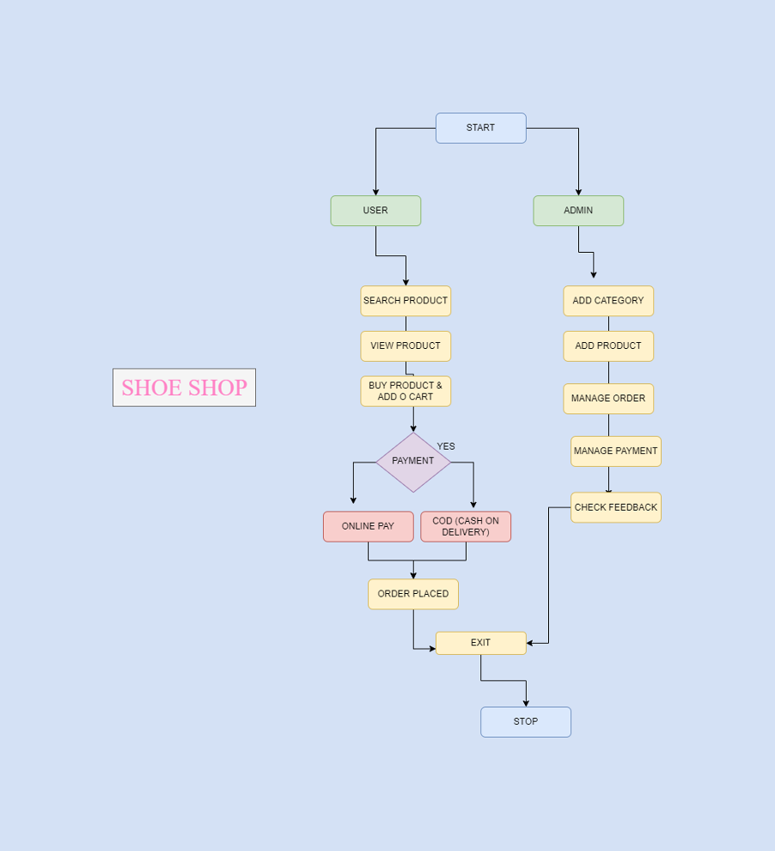

Generated Components & Listed shoes

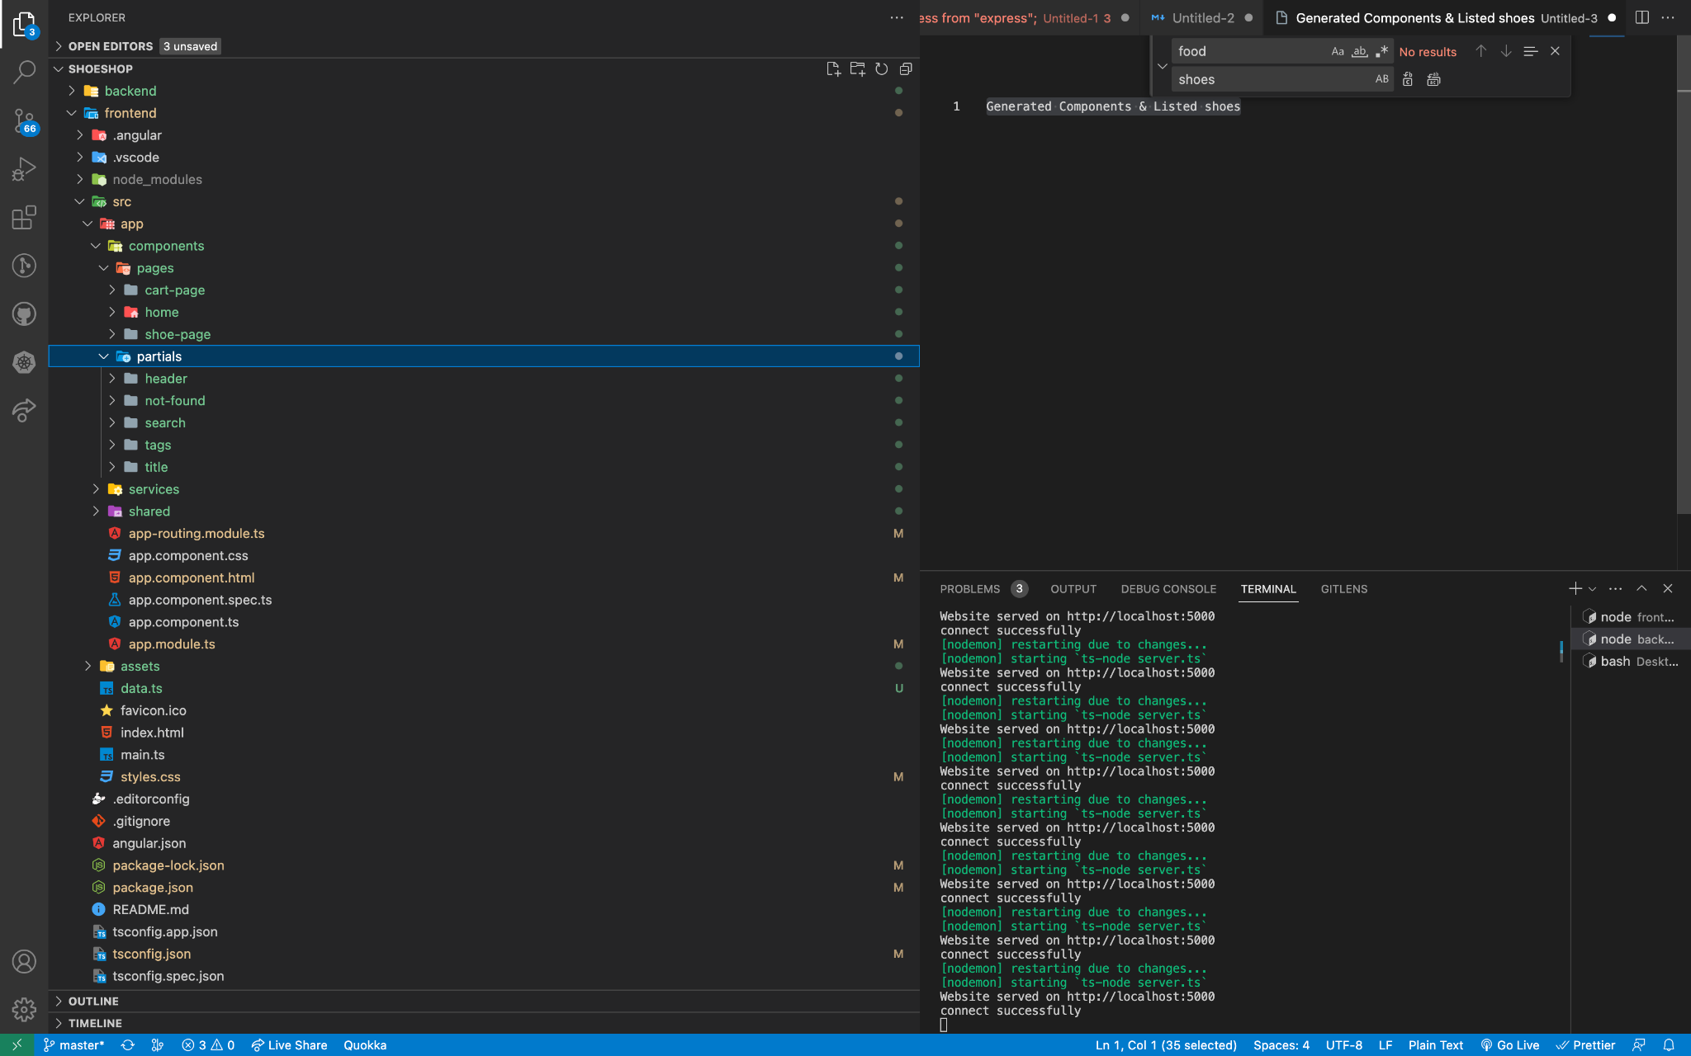

By leveraging the strengths of each of these technologies, we can create a user-friendly and responsive online store that will meet the specific needs of a shoe brand, including features such as product catalogs, shopping cart, checkout, payment processing, and more. With this project, we aim to provide a seamless shopping experience for customers while also ensuring that the website is easy to manage and maintain for the brand owners.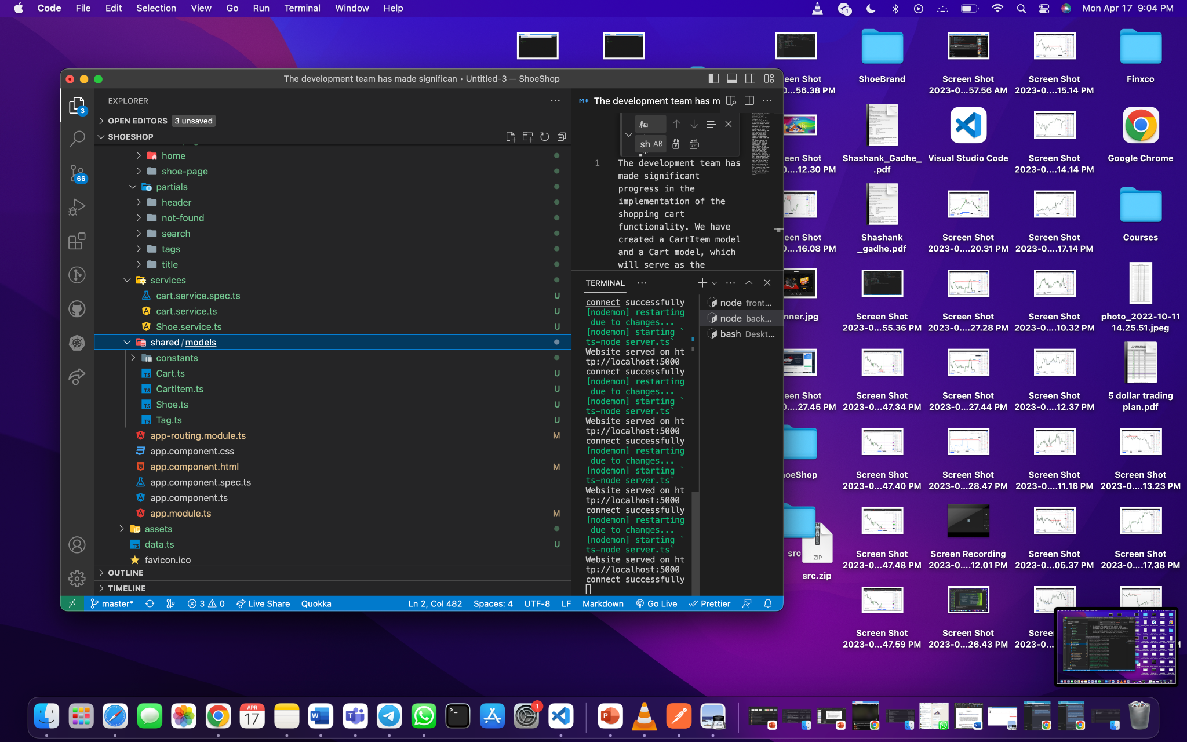

Created shoes model and data.ts for storing database Added sample shoes & images to assets established shoes service, home and search component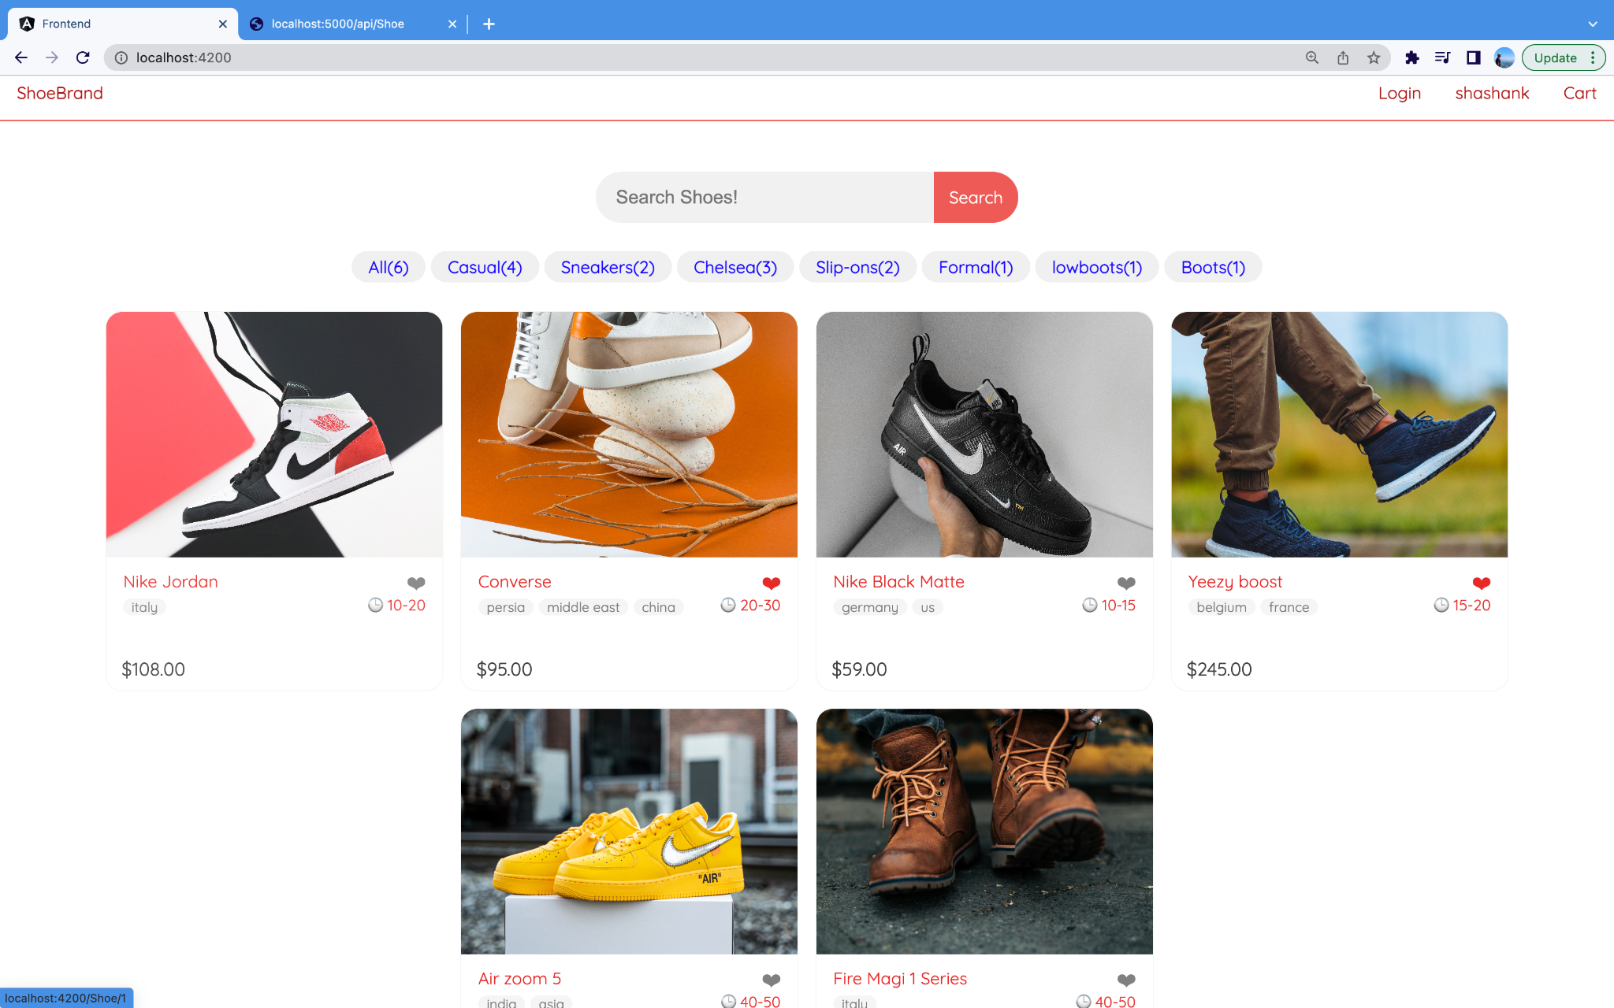

Fig 1. Home page

Included a new function in the shoe service, created a search route, and added search results to the home component. Additionally, I have generated a new search component and integrated it into the home component. I have also created a tags bar that allows for filtering based on the category.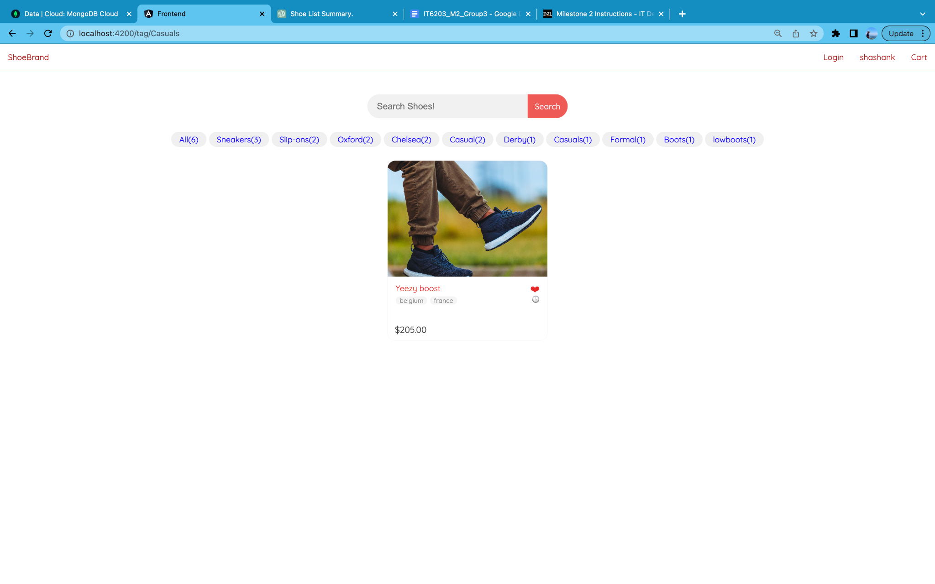

Fig 2. Filtered using tags components (<http://localhost:4200/tag/Casuals>)

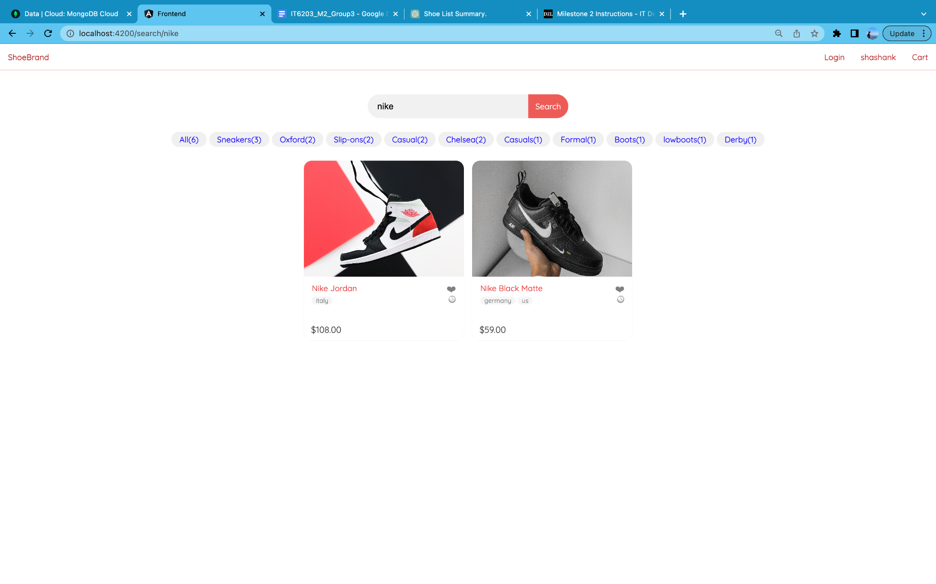

Fig 3. Filtered using Search component ( <http://localhost:4200/search/nike> )

Created shoe page Components would be that it contains various elements such as images, detailed pricing, and information about the shoe's origin. It places more emphasis on visual aids to showcase the shoe's features and provides a clear understanding of its pricing and where it comes from.

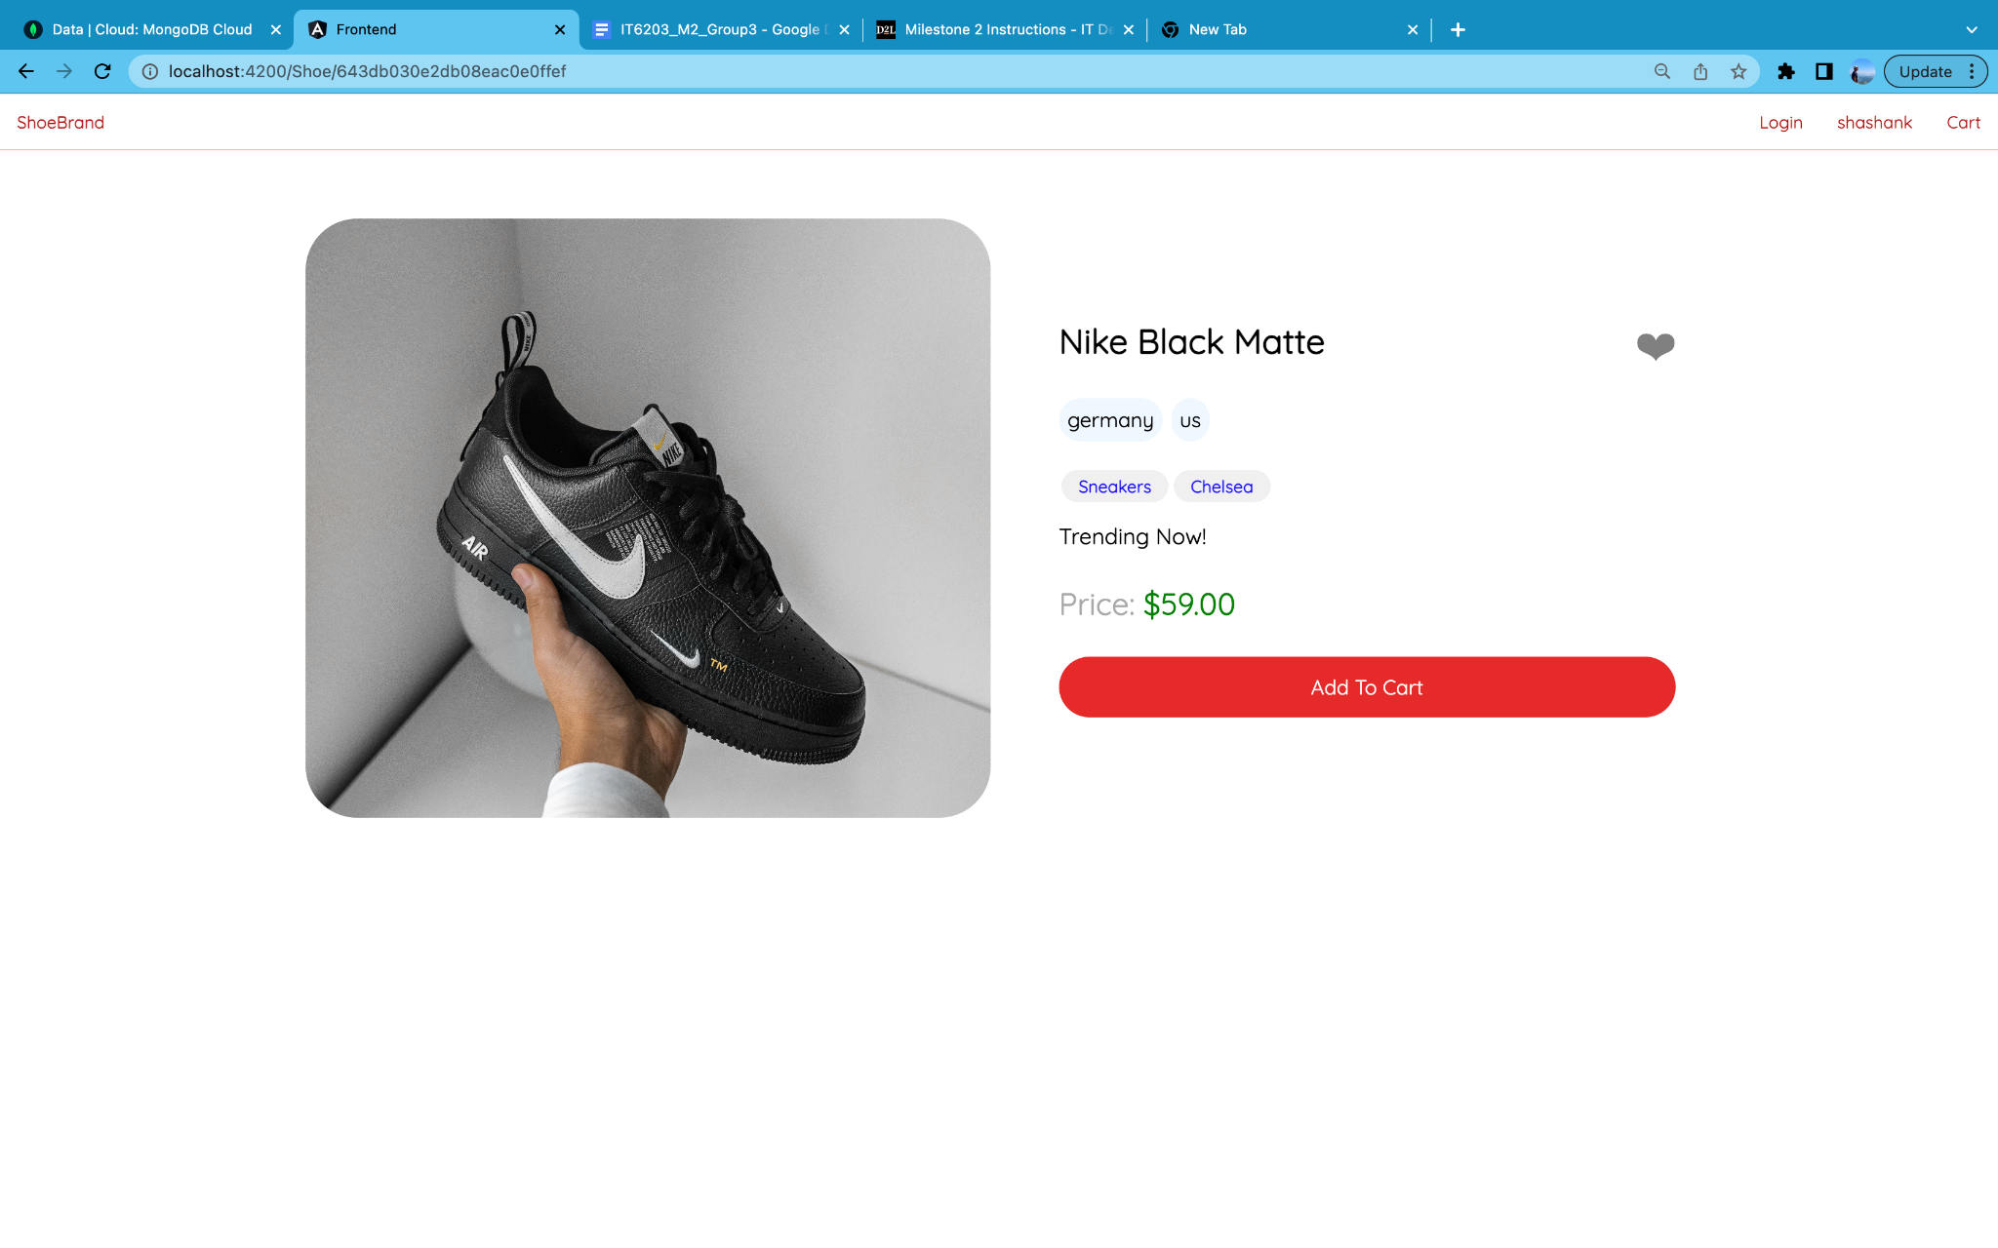

Fig 4. Shoe page Components (<http://localhost:4200/Shoe/643db030e2db08eac0e0ffef> )

[[643db030e2db08eac0e0ffef](http://localhost:4200/Shoe/643db030e2db08eac0e0ffef) shoe id generated from backend]

The development team has made significant progress in the implementation of the shopping cart functionality. We have created a CartItem model and a Cart model, which will serve as the backbone for storing and managing the items that users add to their carts. Additionally, we have generated a Cart service, which will handle the business logic for adding and removing items from the cart.

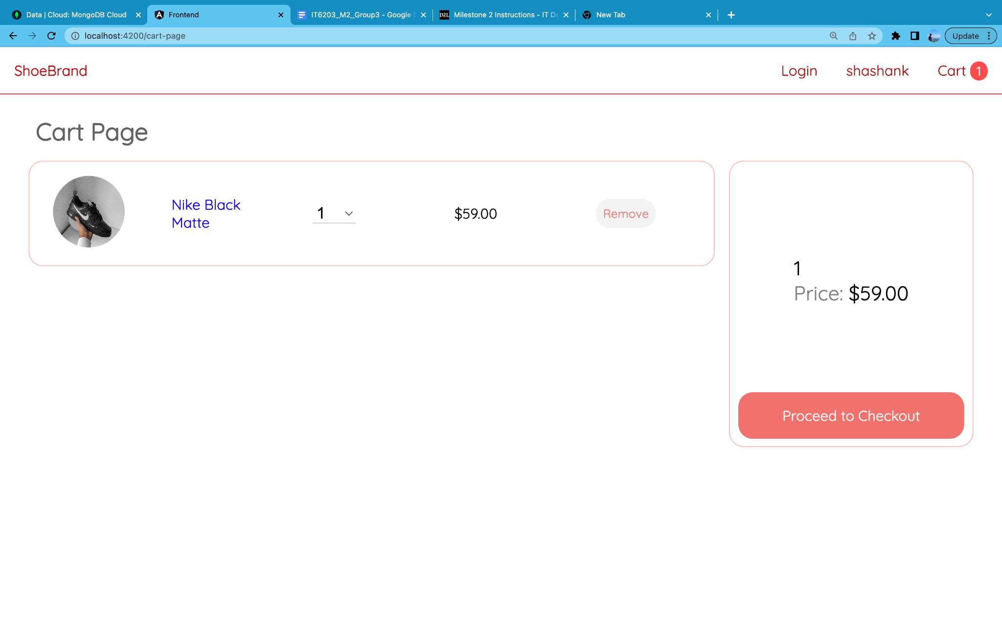

Fig 5. Cart page Components (<http://localhost:4200/cart-page> )

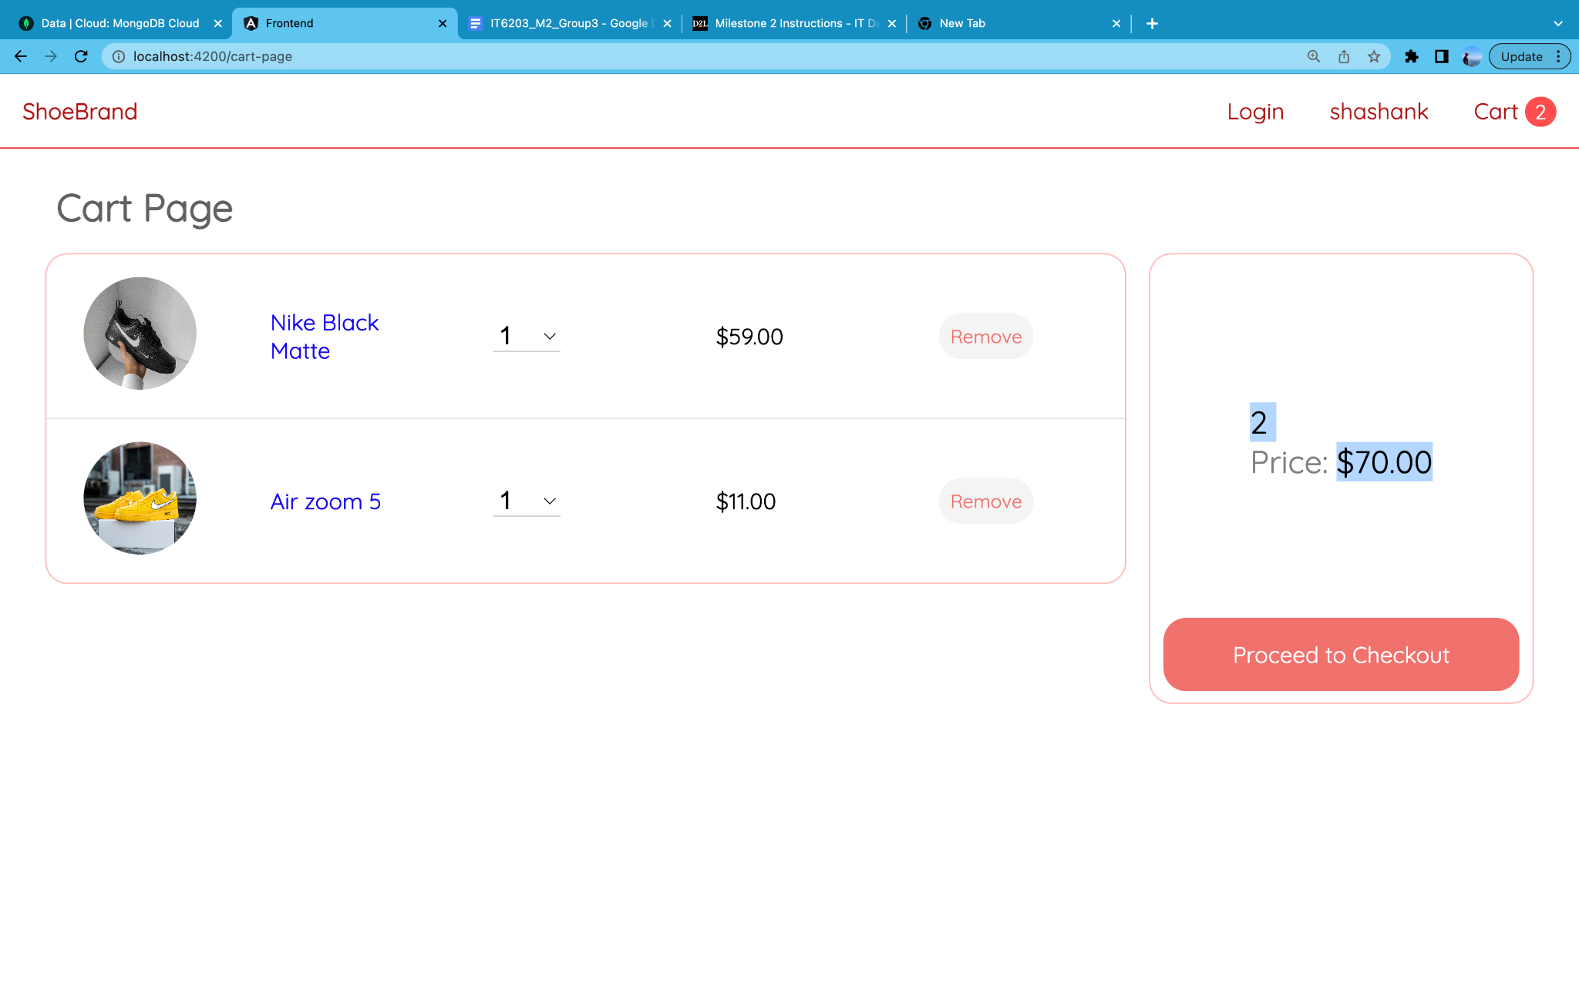

Fig 6. Price and Quantity Getting Updated accordingly

To make it easier for users to add items to their carts, the team has added a "Add to Cart" button on the shoes page. This button will trigger the Cart service to add the selected item to the user's cart. Finally, the team has generated a Cart page component that will display the items currently in the user's cart and allow them to adjust quantities or remove items as needed.With these features in place, users will be able to easily add items to their cart while browsing the site and manage their selections as they continue to shop.

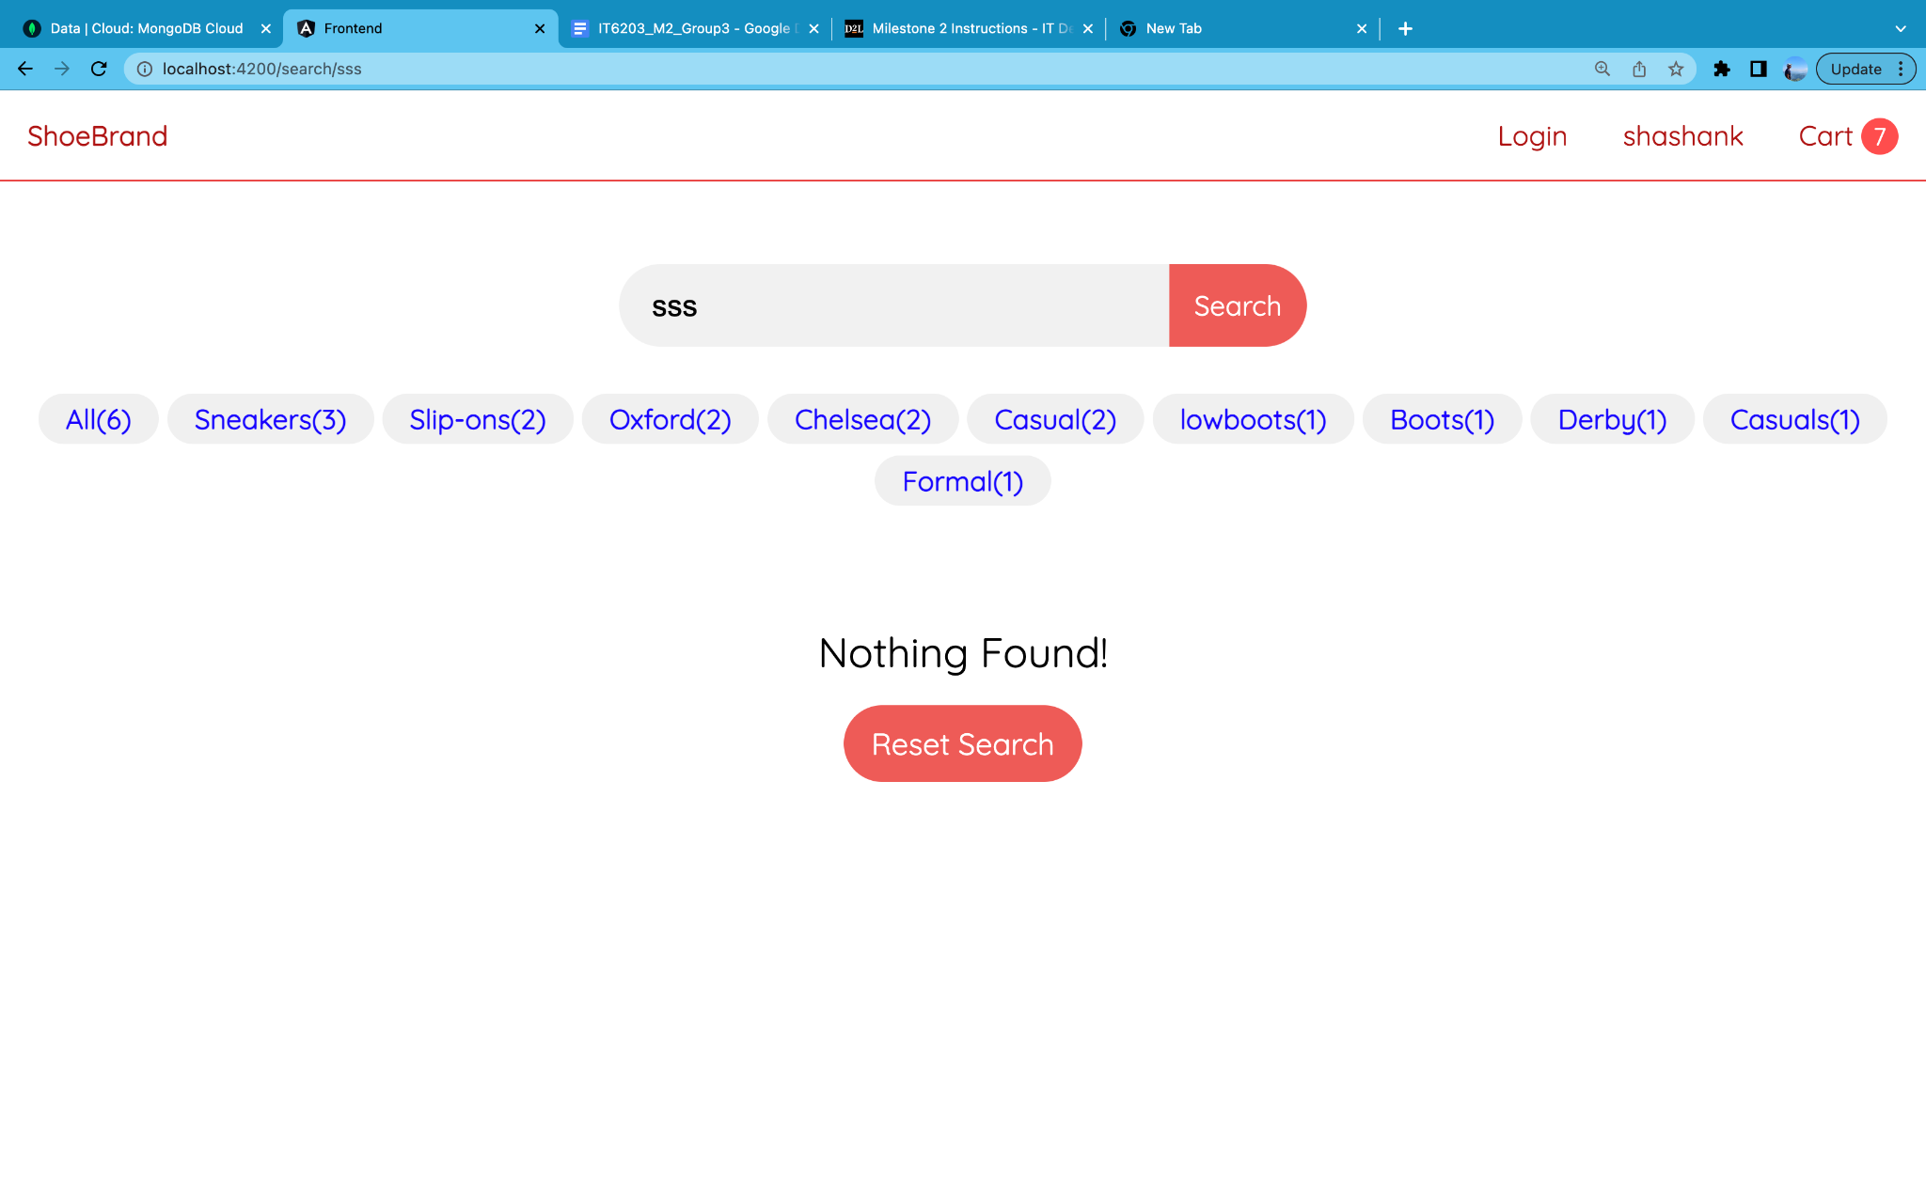

Fig 7. Not Found page

Backend API TESTING

* http://localhost:5000/api/Shoe

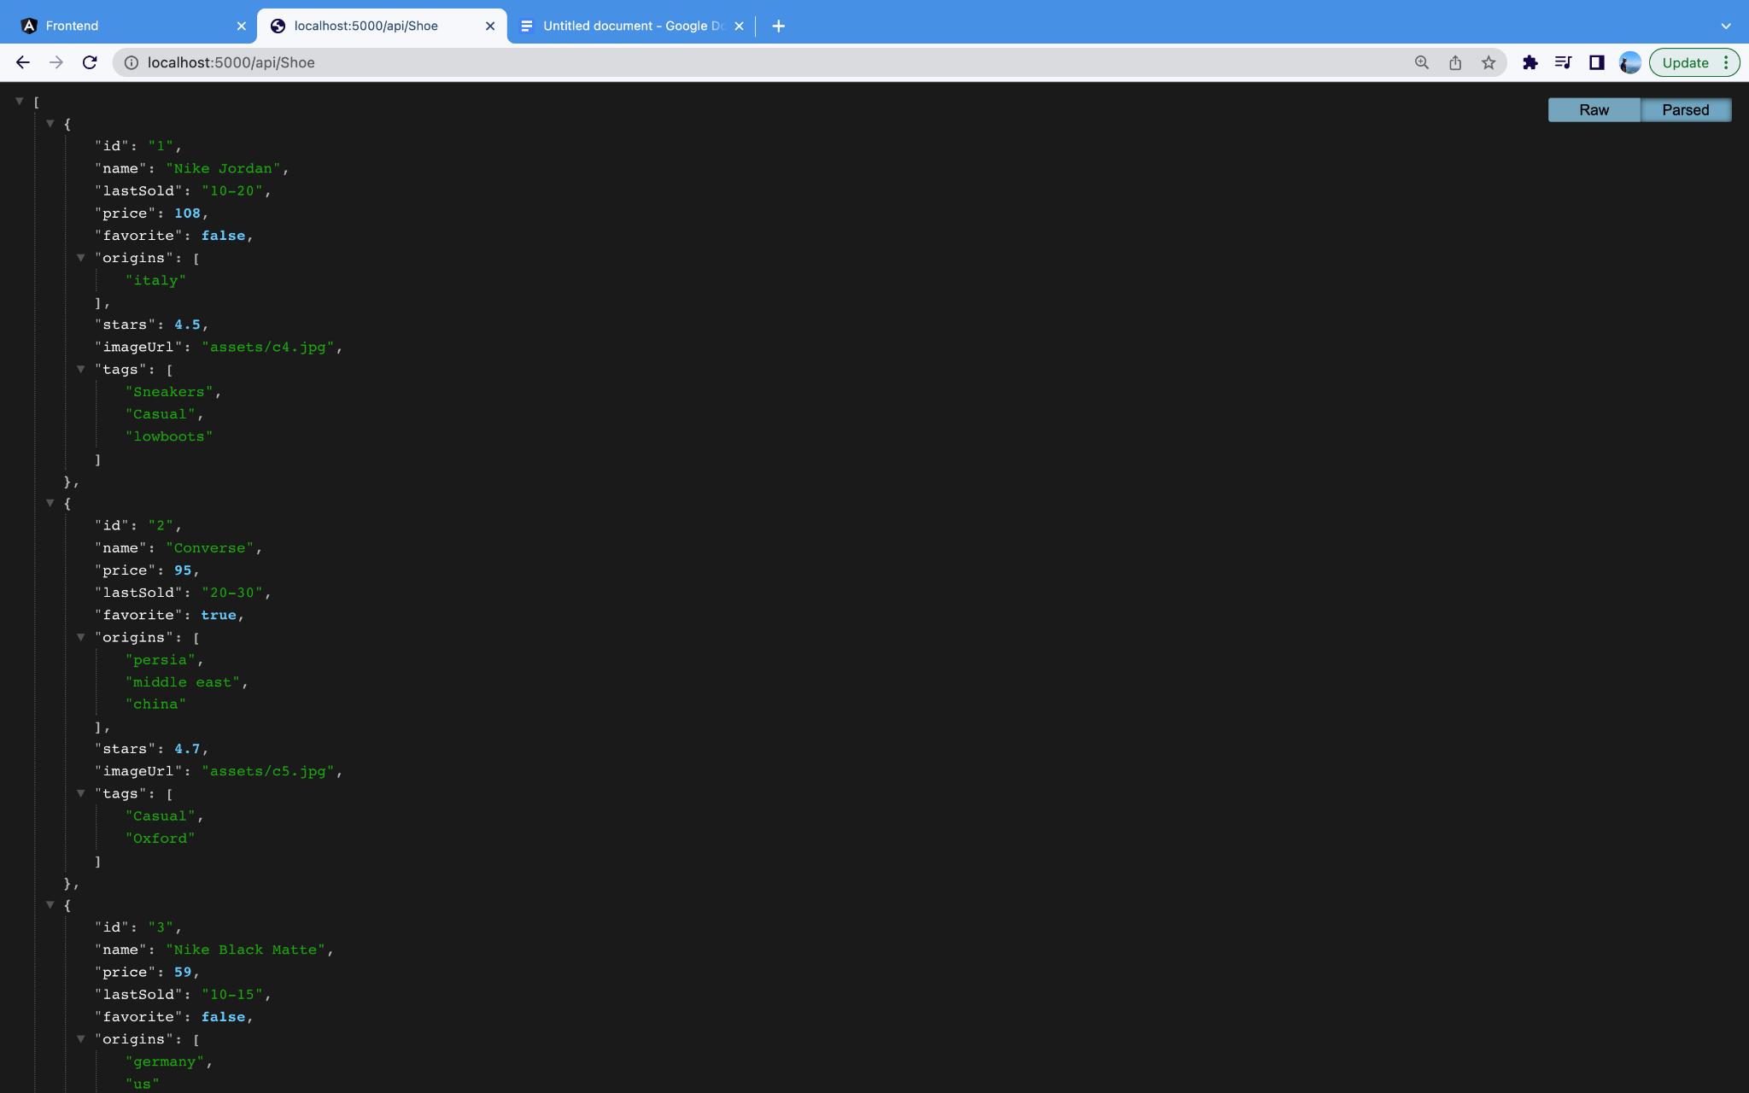

* http://localhost:5000/api/Shoe/search/nike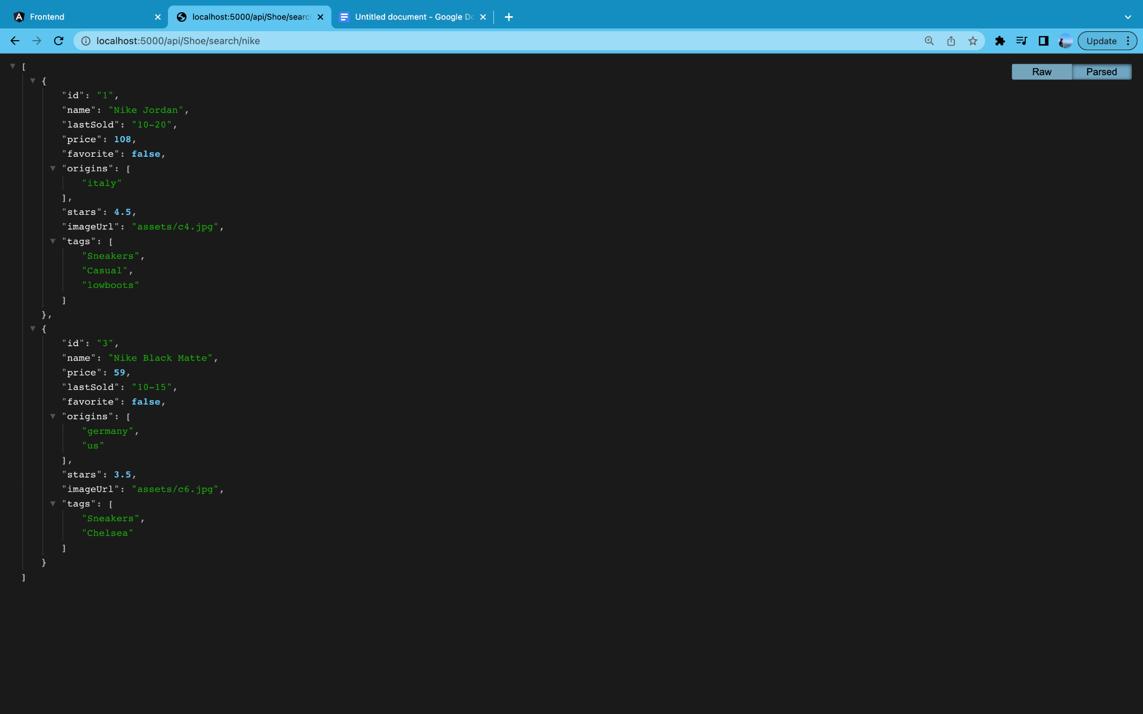
* http://localhost:5000/api/Shoe/tags

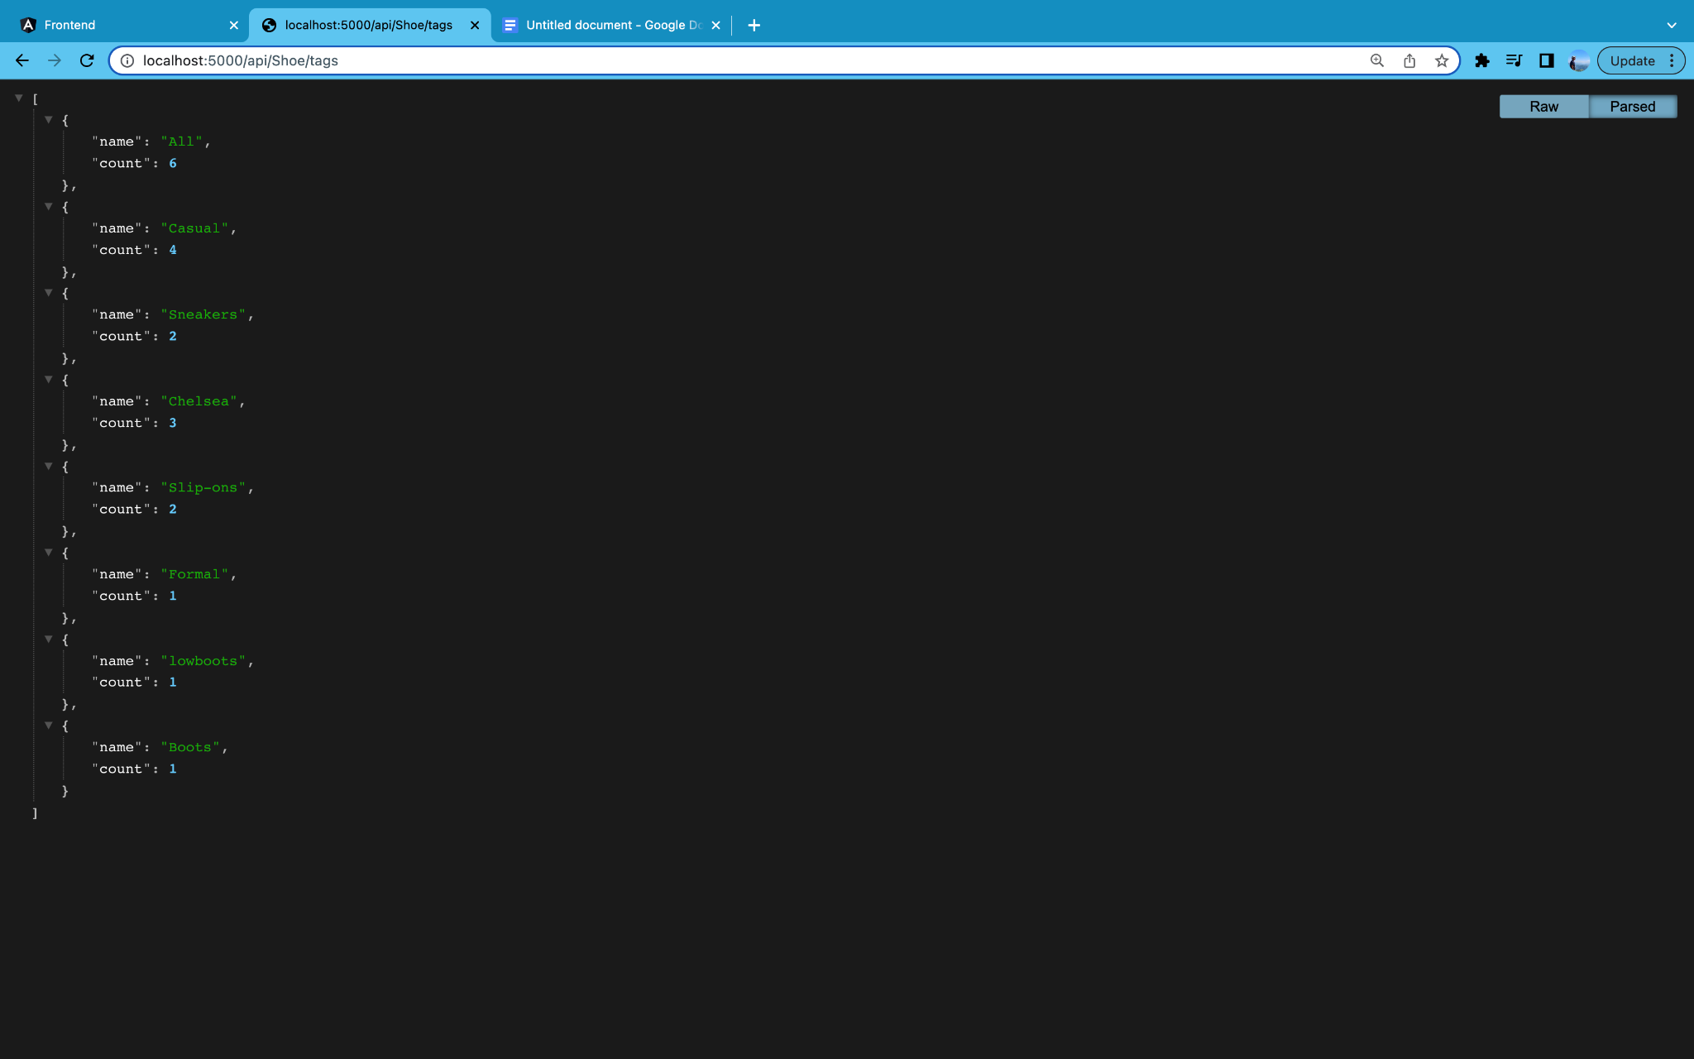

* <http://localhost:5000/api/Shoe/3>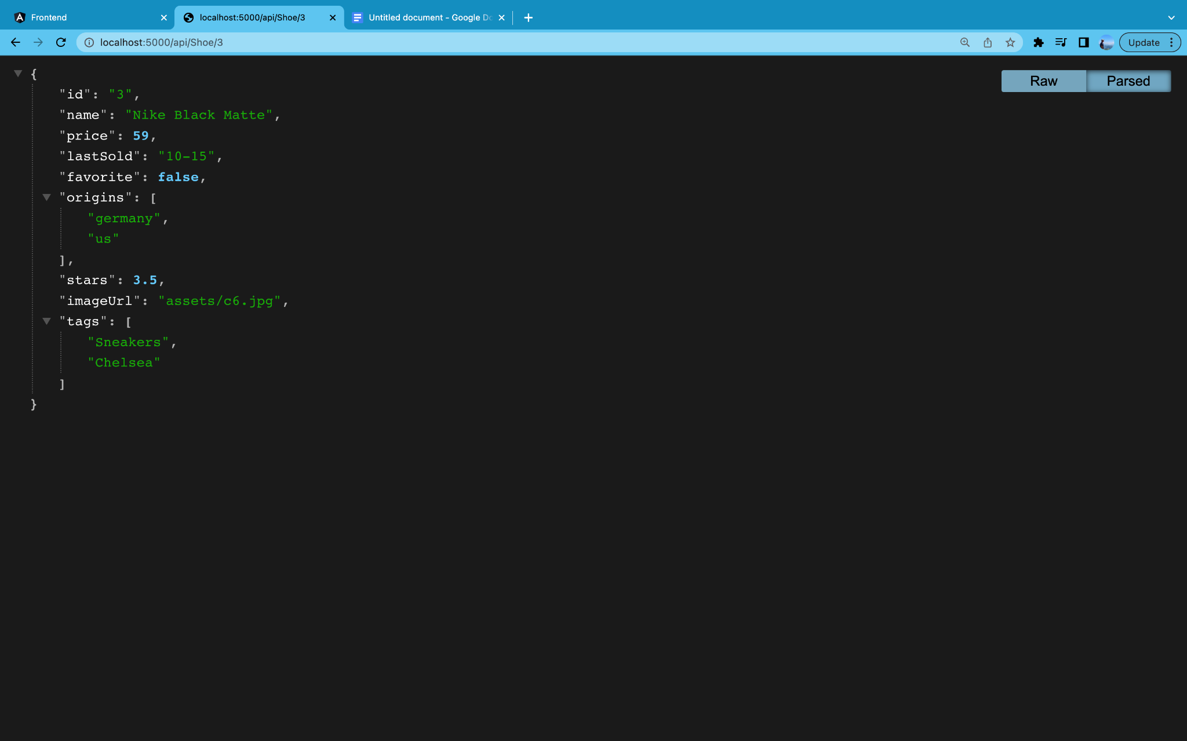

MONGO DATABASE CONNECTION

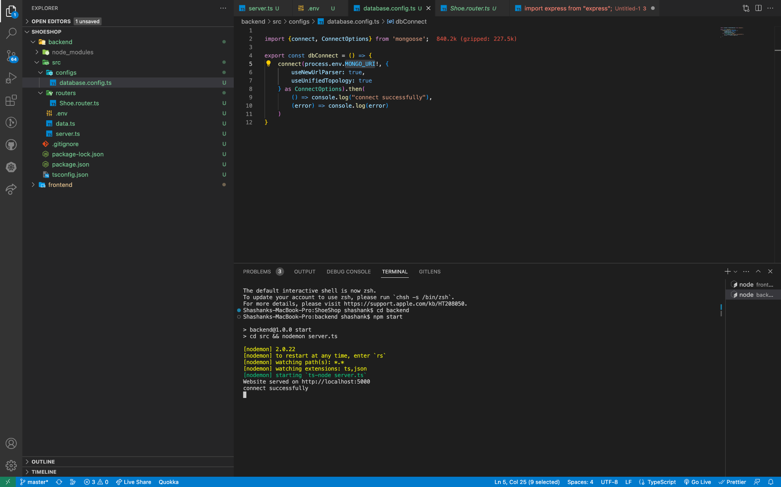

SEEDED DATA TO MONGODB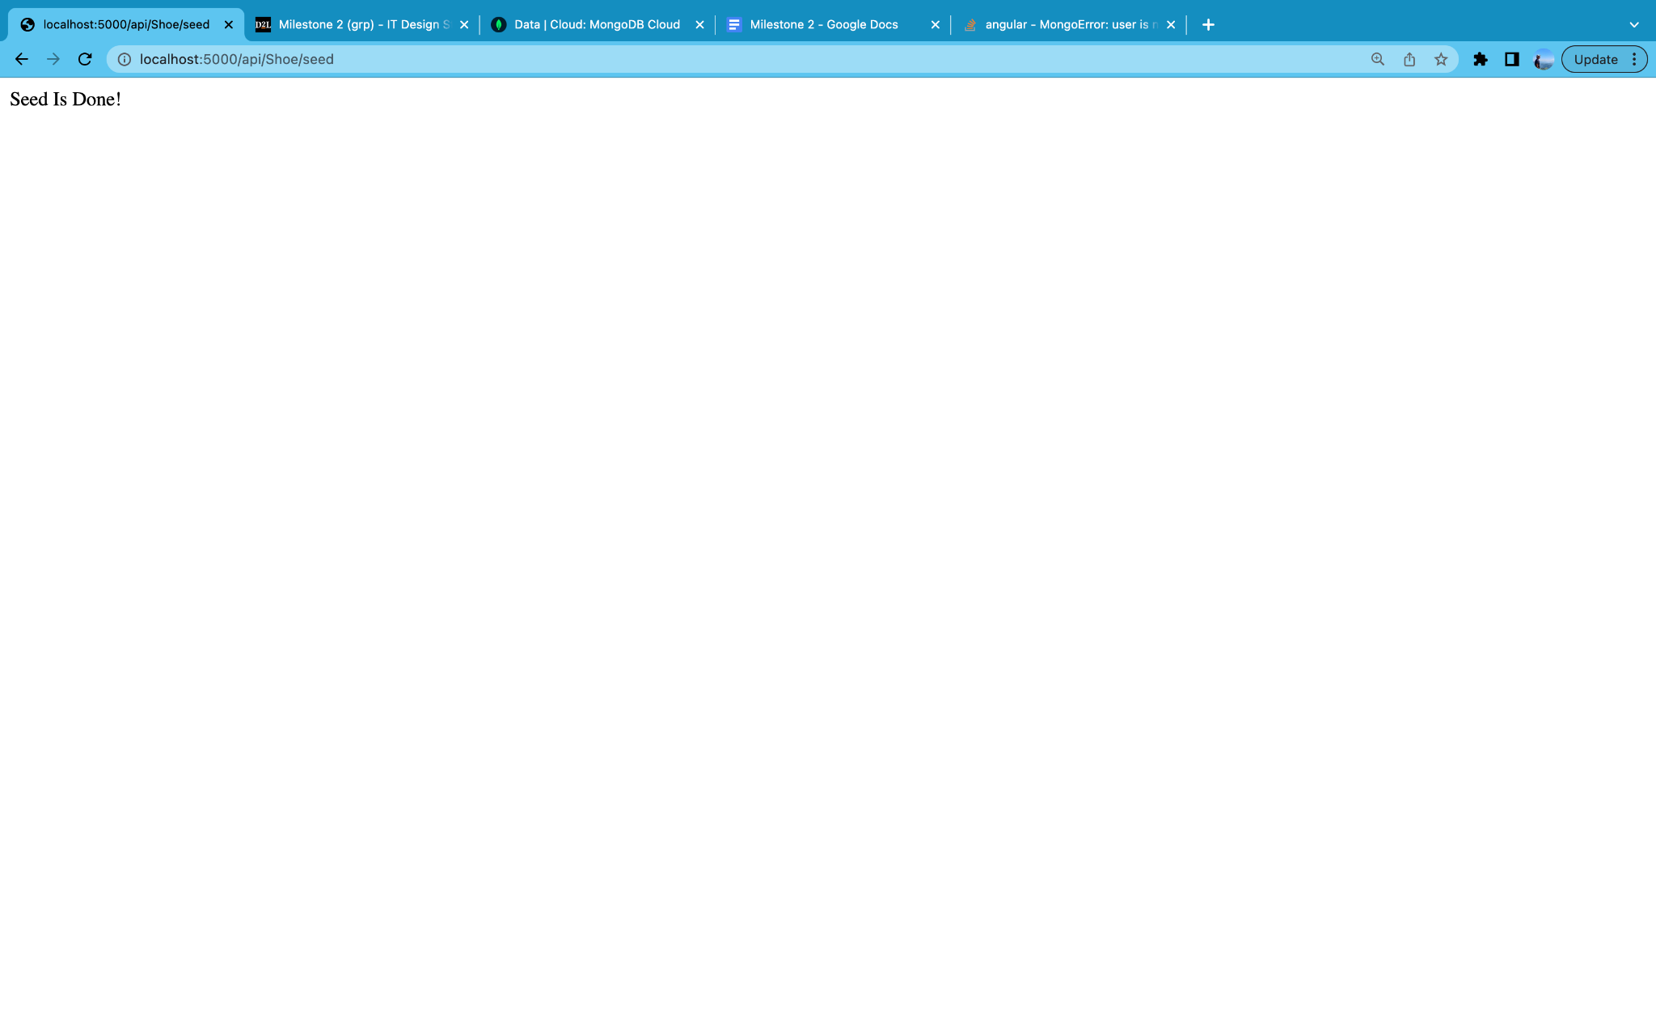

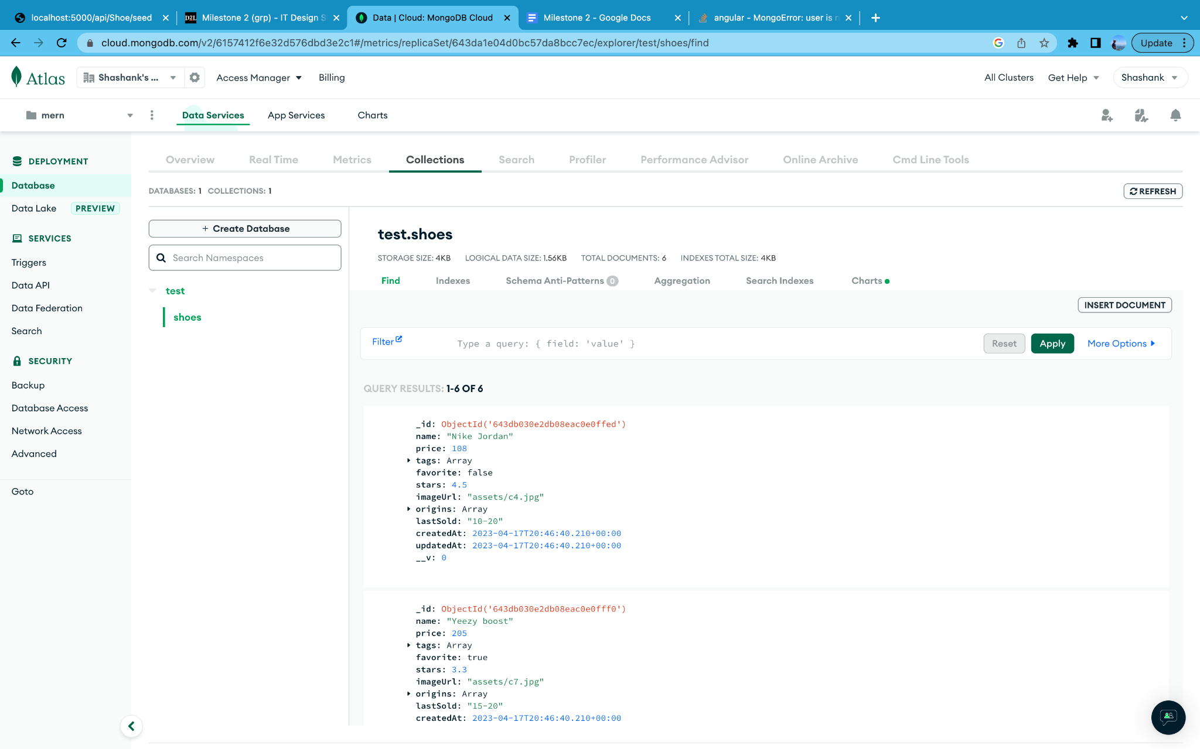

Data retrieving and updated successfully from Mongodb

<http://localhost:4200/Shoe/643db030e2db08eac0e0fff0>

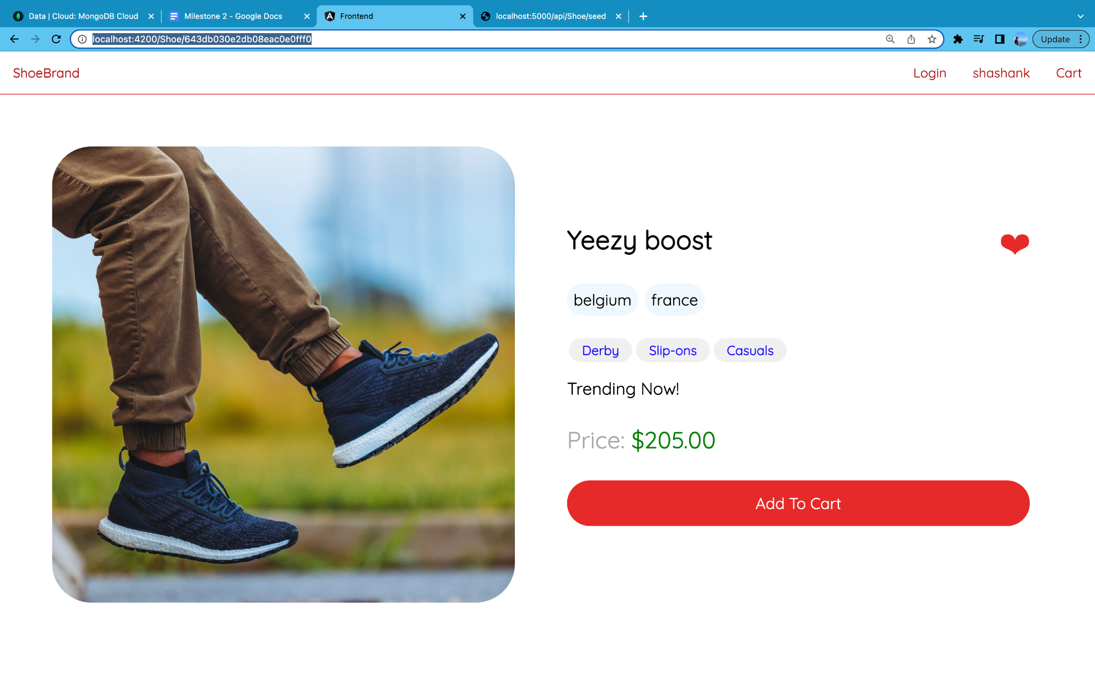

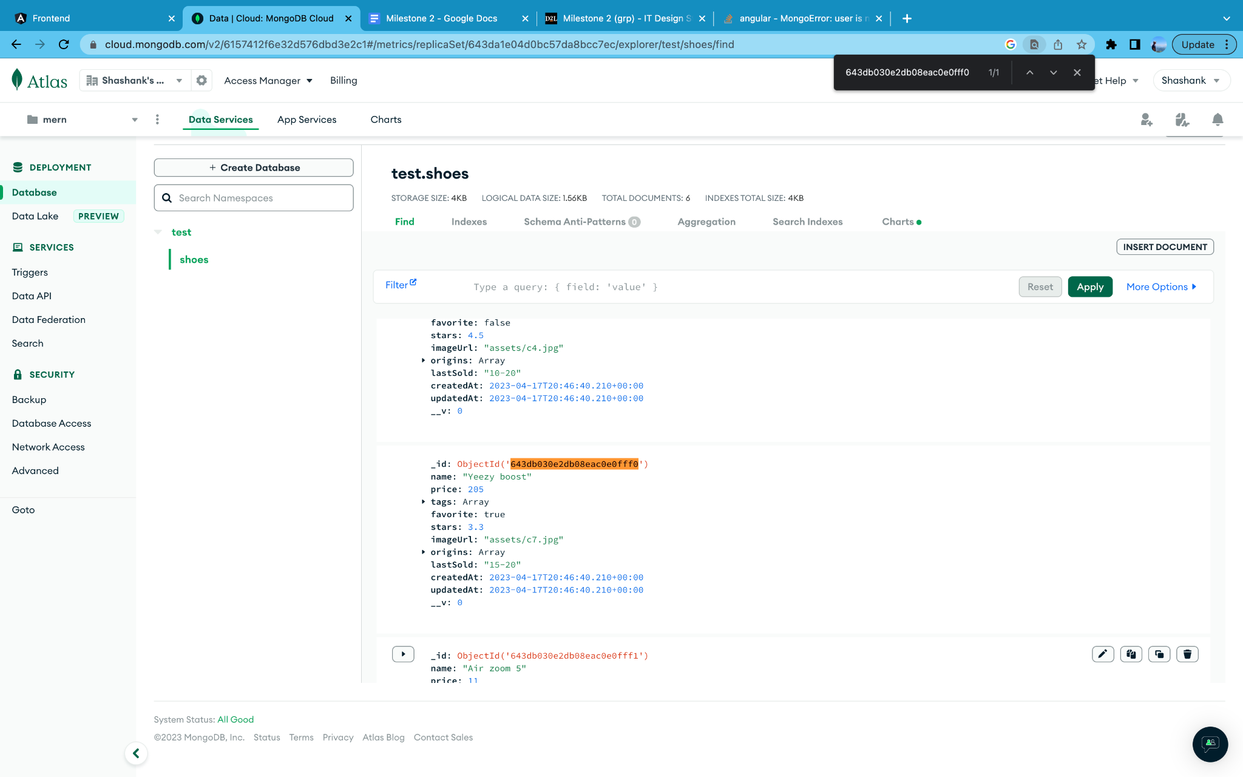

**Login and Register Component**

Components have been developed for the Login page, including an Input Container, Input Validation, Text Input, and Default Button. The Input Container is used to contain the text input and input validation components, which are essential for capturing and validating user input in real-time. The Text Input component is used to capture user input such as email and password, while the Input Validation component is used to validate the user input and display any errors if necessary. The Default Button component is used to submit the form or initiate other actions, such as resetting the input fields or navigating to another page. These components are integral in creating a user-friendly and functional login page that meets the specific needs of the ecommerce web application.

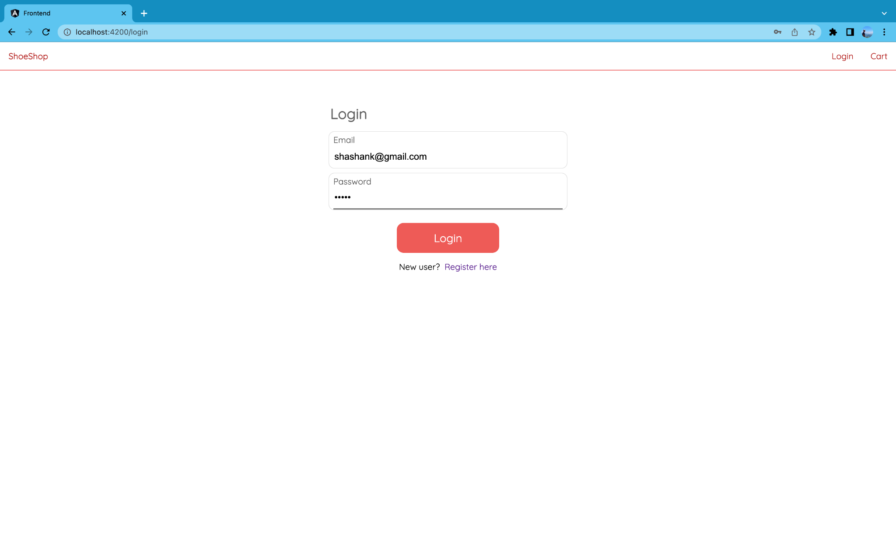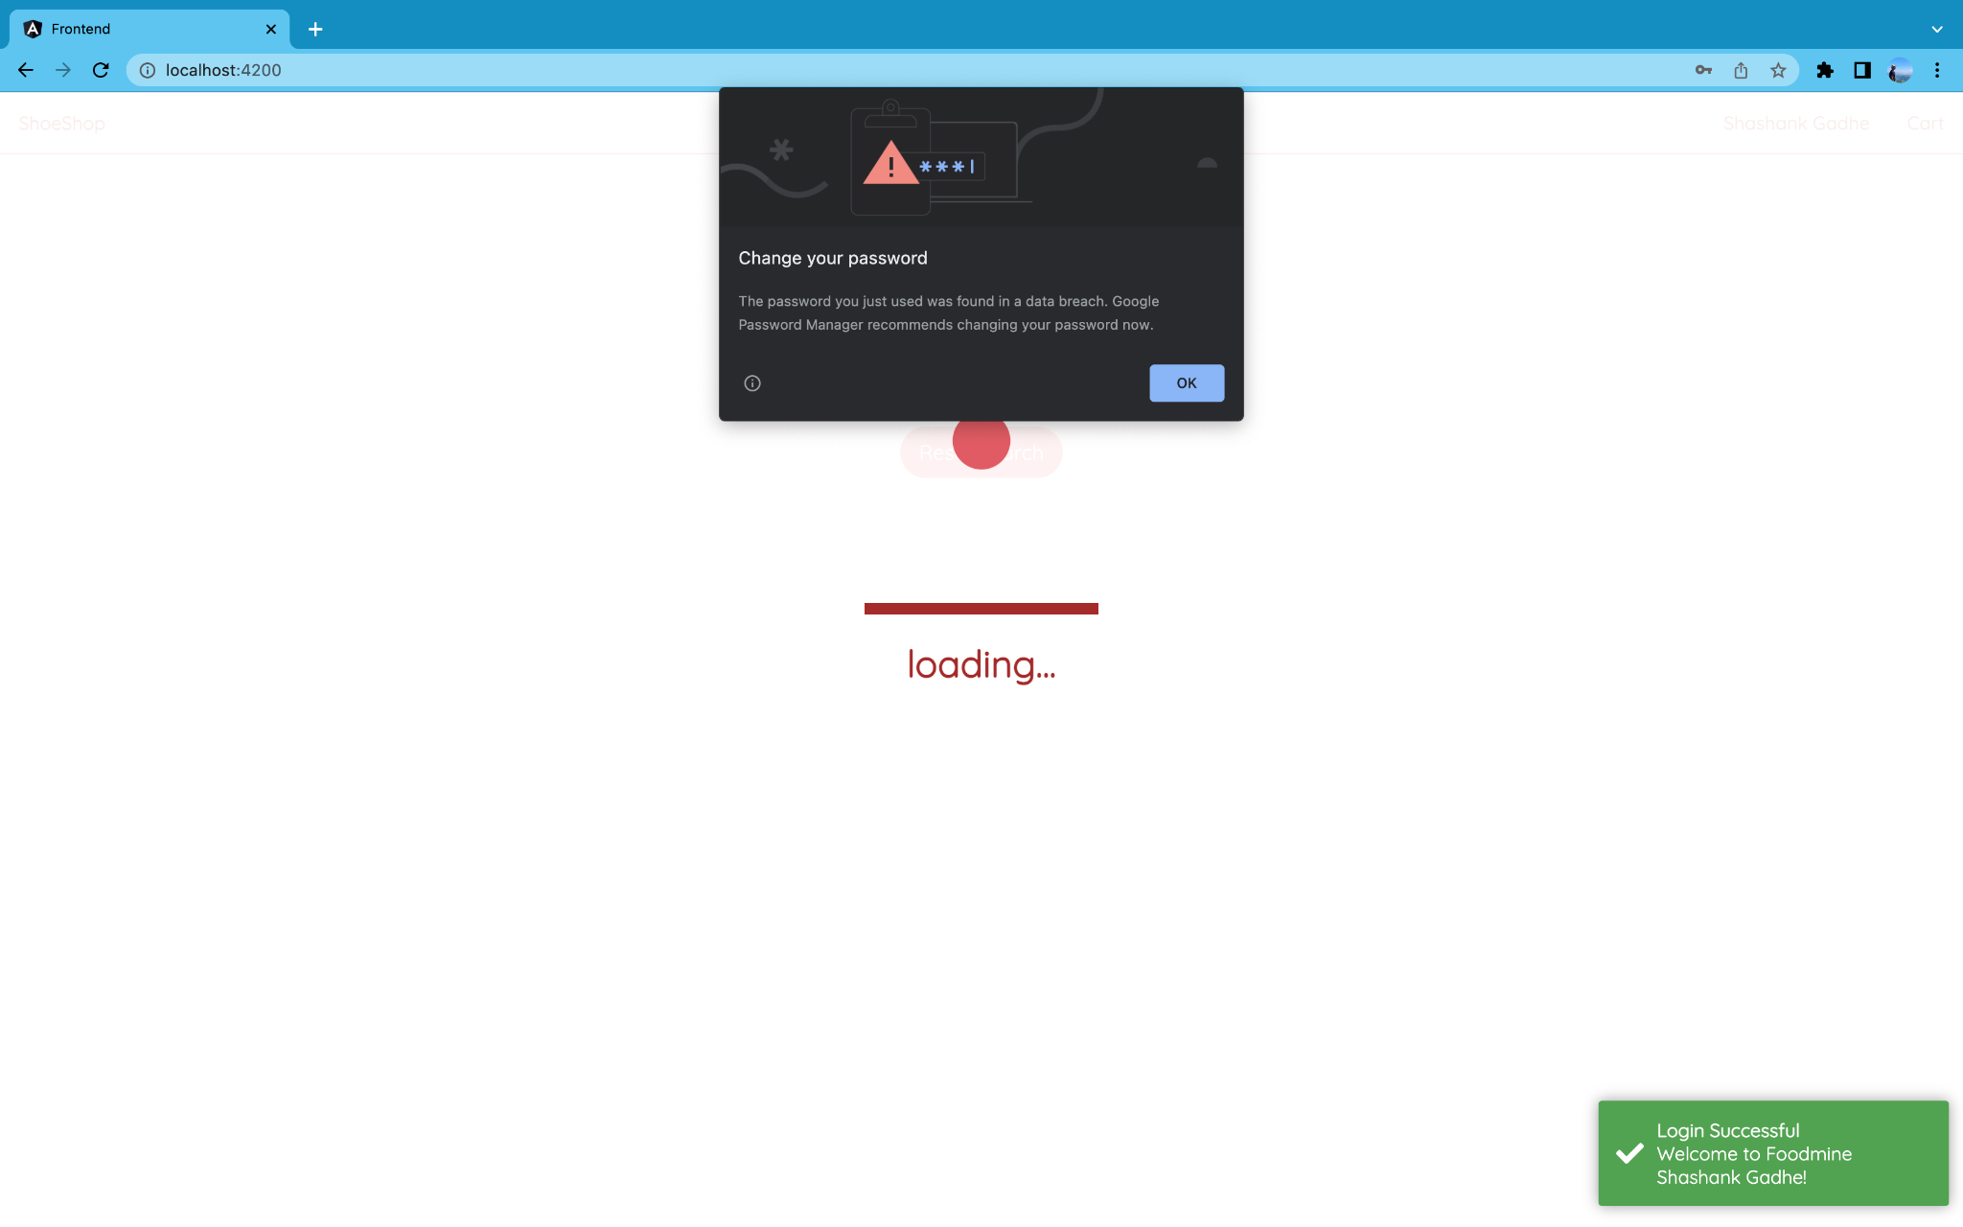

**Register Page**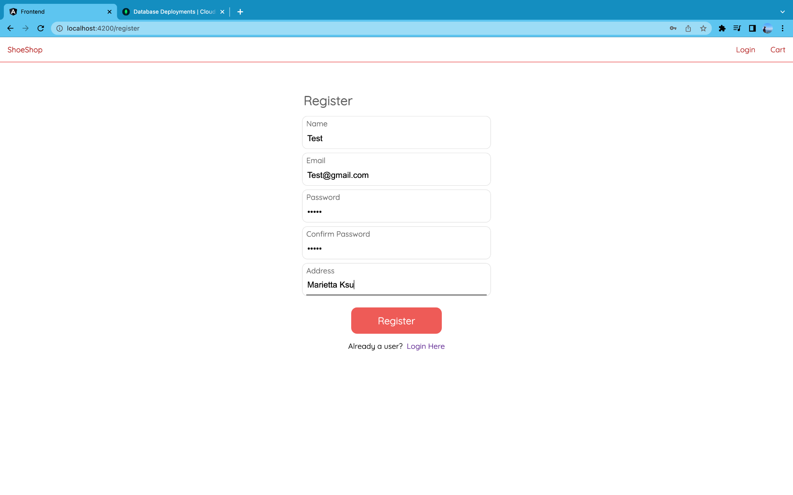

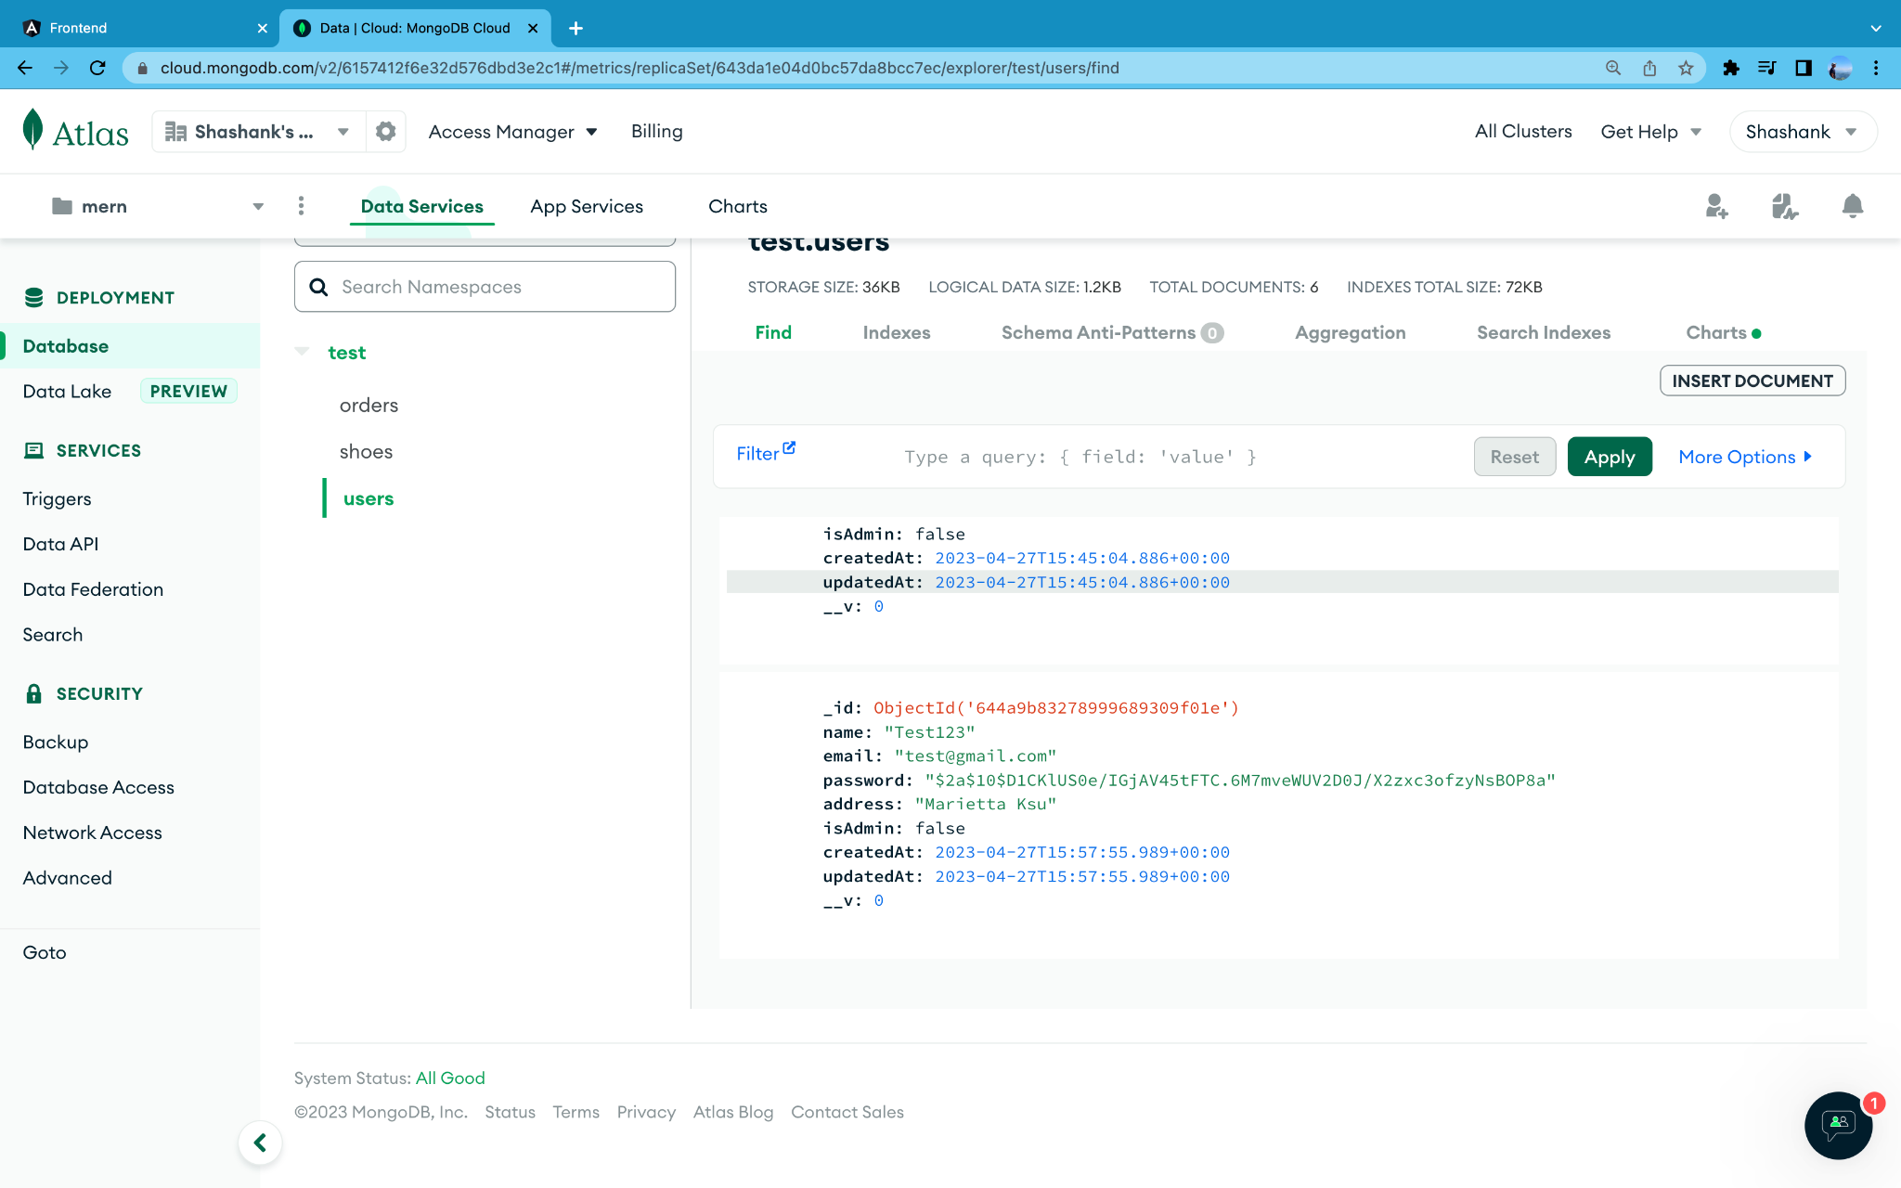

**Loading Component**

For Ease of Representation and User interface we have implemented loading.svg animation it displays while the data is loaded from the server i.e backend.

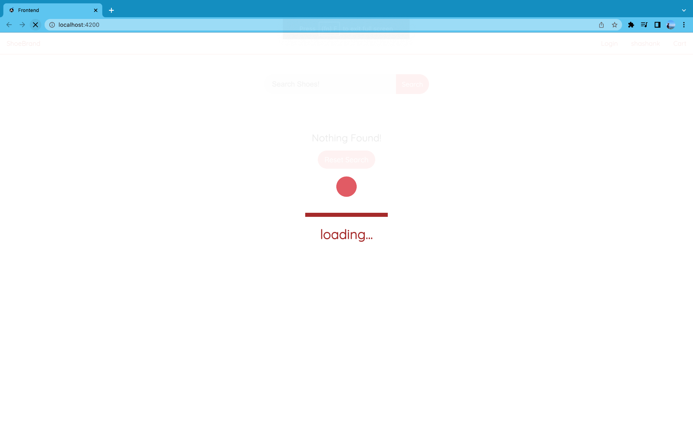

**Checkout Component**

As further implementation to checkout the products from cart page we have created Order component which includes of getting the order details that includes name and address and disclosing the order details for the final confirmation.

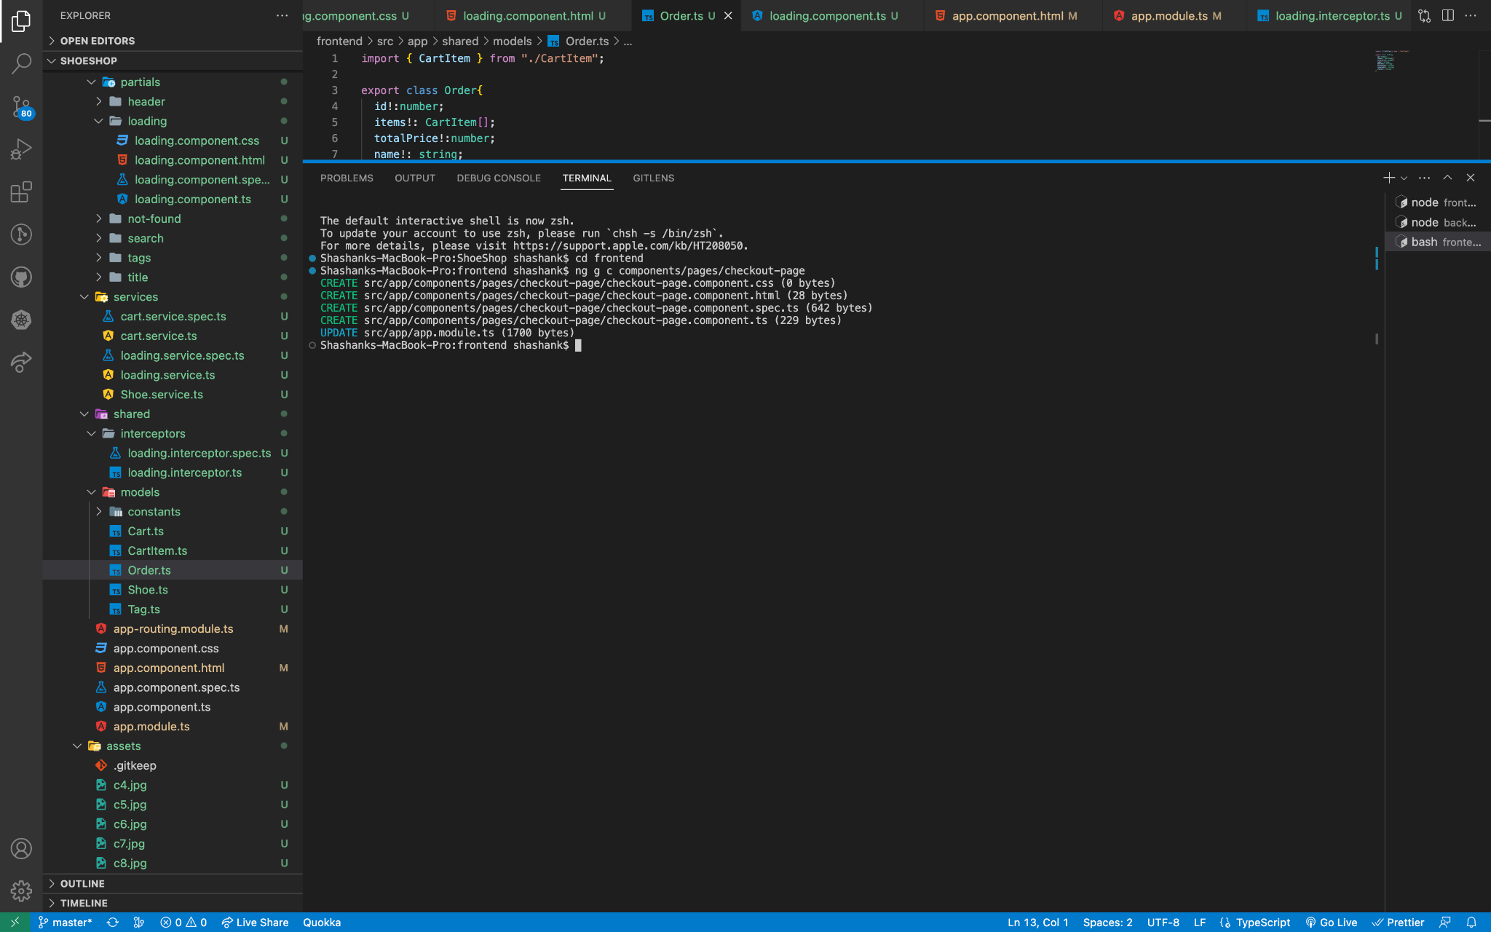

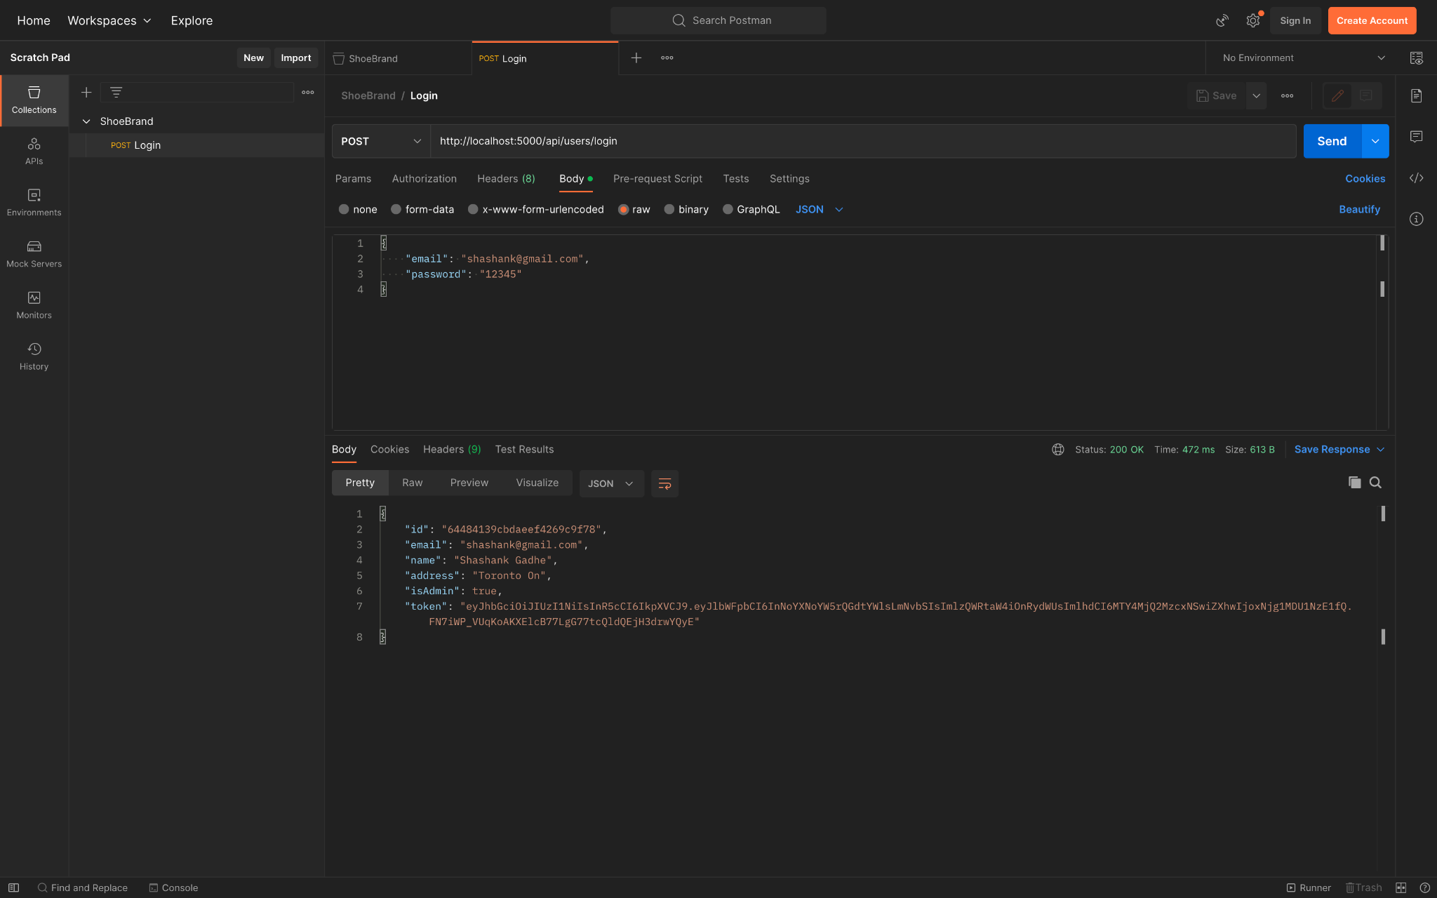

**Order Form data is retrieved successfully (Tested using PostMan)**

The order form data is retrieved successfully when tested using Postman. Postman is an excellent tool for testing APIs and verifying that data is being sent and received correctly. Retrieving order form data successfully is a crucial step in the process of building an ecommerce website as it is the backbone of the entire ordering process. It is important to continue testing and verifying that the data is being retrieved correctly from the order form as it is an essential part of ensuring that the website functions correctly and provides a positive user experience for customers. If any issues arise, they can be identified and resolved promptly, leading to a smoother and more successful ecommerce platform.

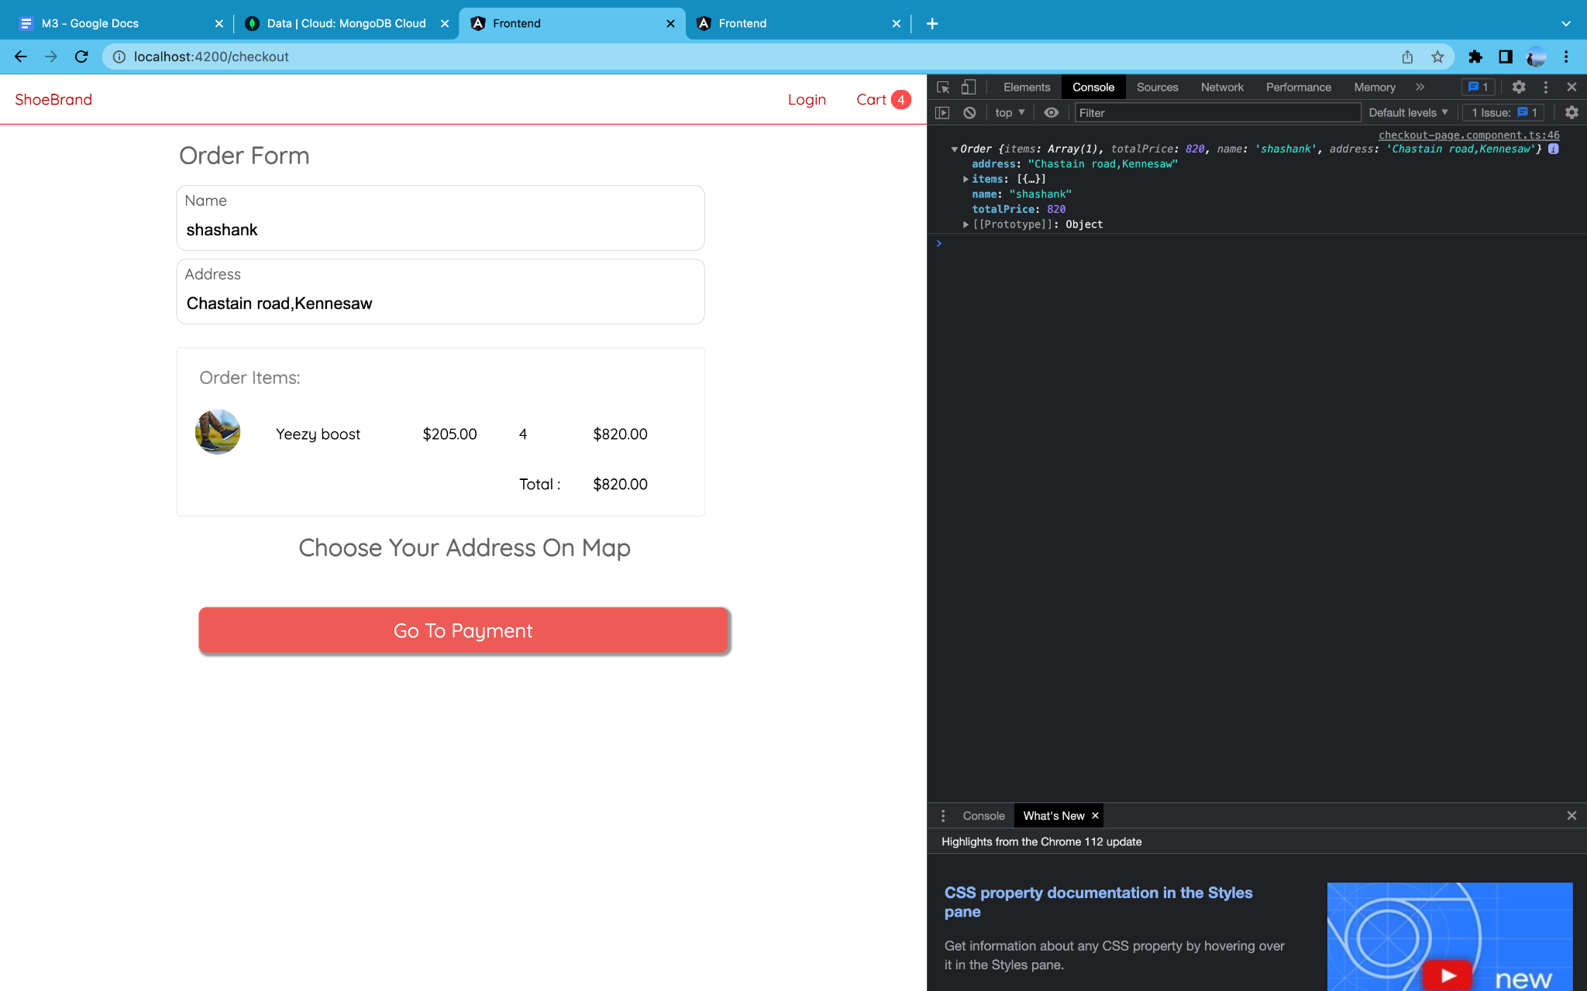

**Integrated Map Component**

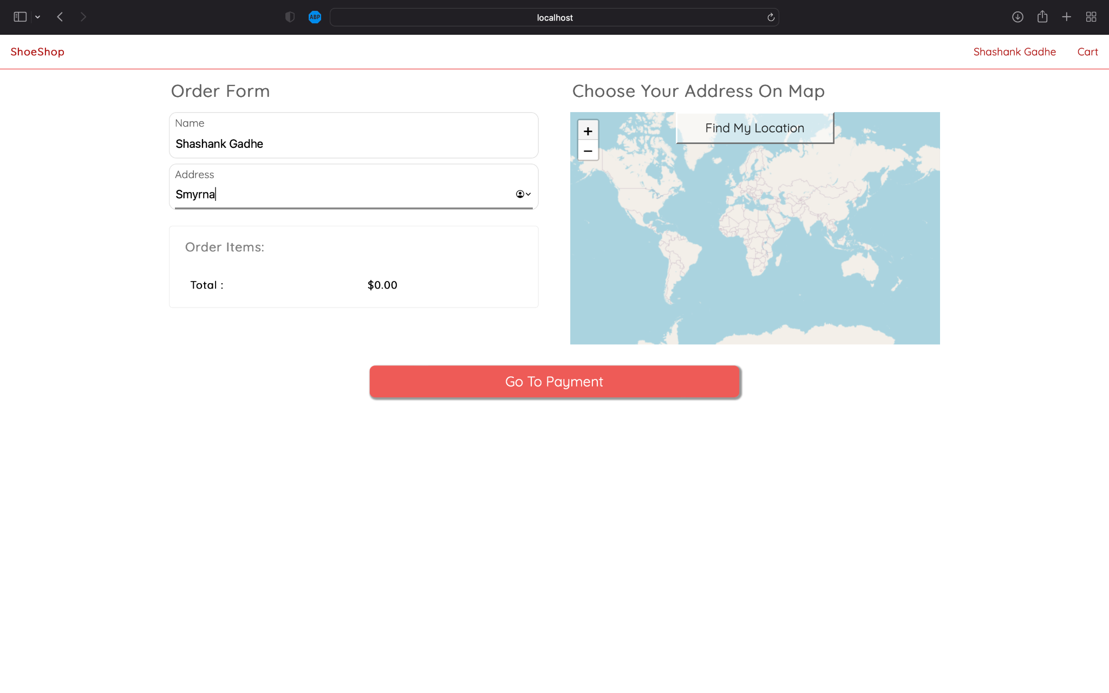

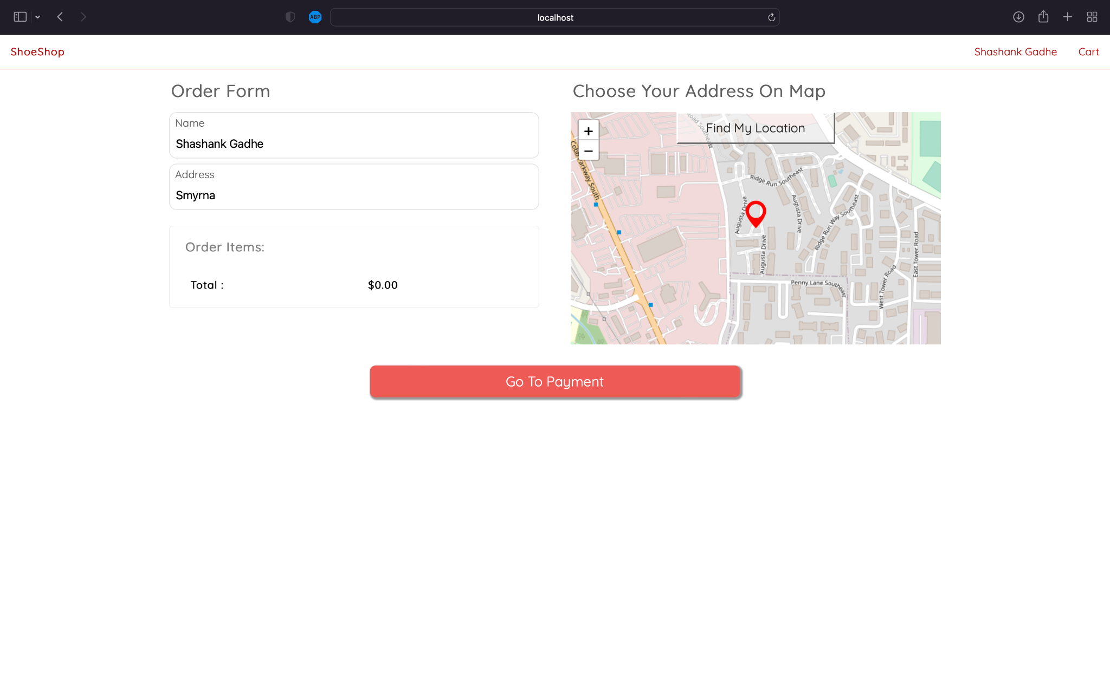

**PayPal Integration**

The ecommerce web application has successfully integrated PayPal as a payment option. This was achieved by generating a new component to handle the PayPal payment flow and obtaining the PayPal client ID, which was added to the application to enable communication with the PayPal API. The PayPal JS was also added to the index.html file, and the PayPal button was set up to provide a seamless payment experience for customers.

The PayPal API was integrated into the order router, allowing for secure payment information to be passed to and from the PayPal sandbox account. By adding PayPal, the ecommerce platform can offer a widely accepted and trusted payment method, increasing customer satisfaction and the likelihood of successful transactions.

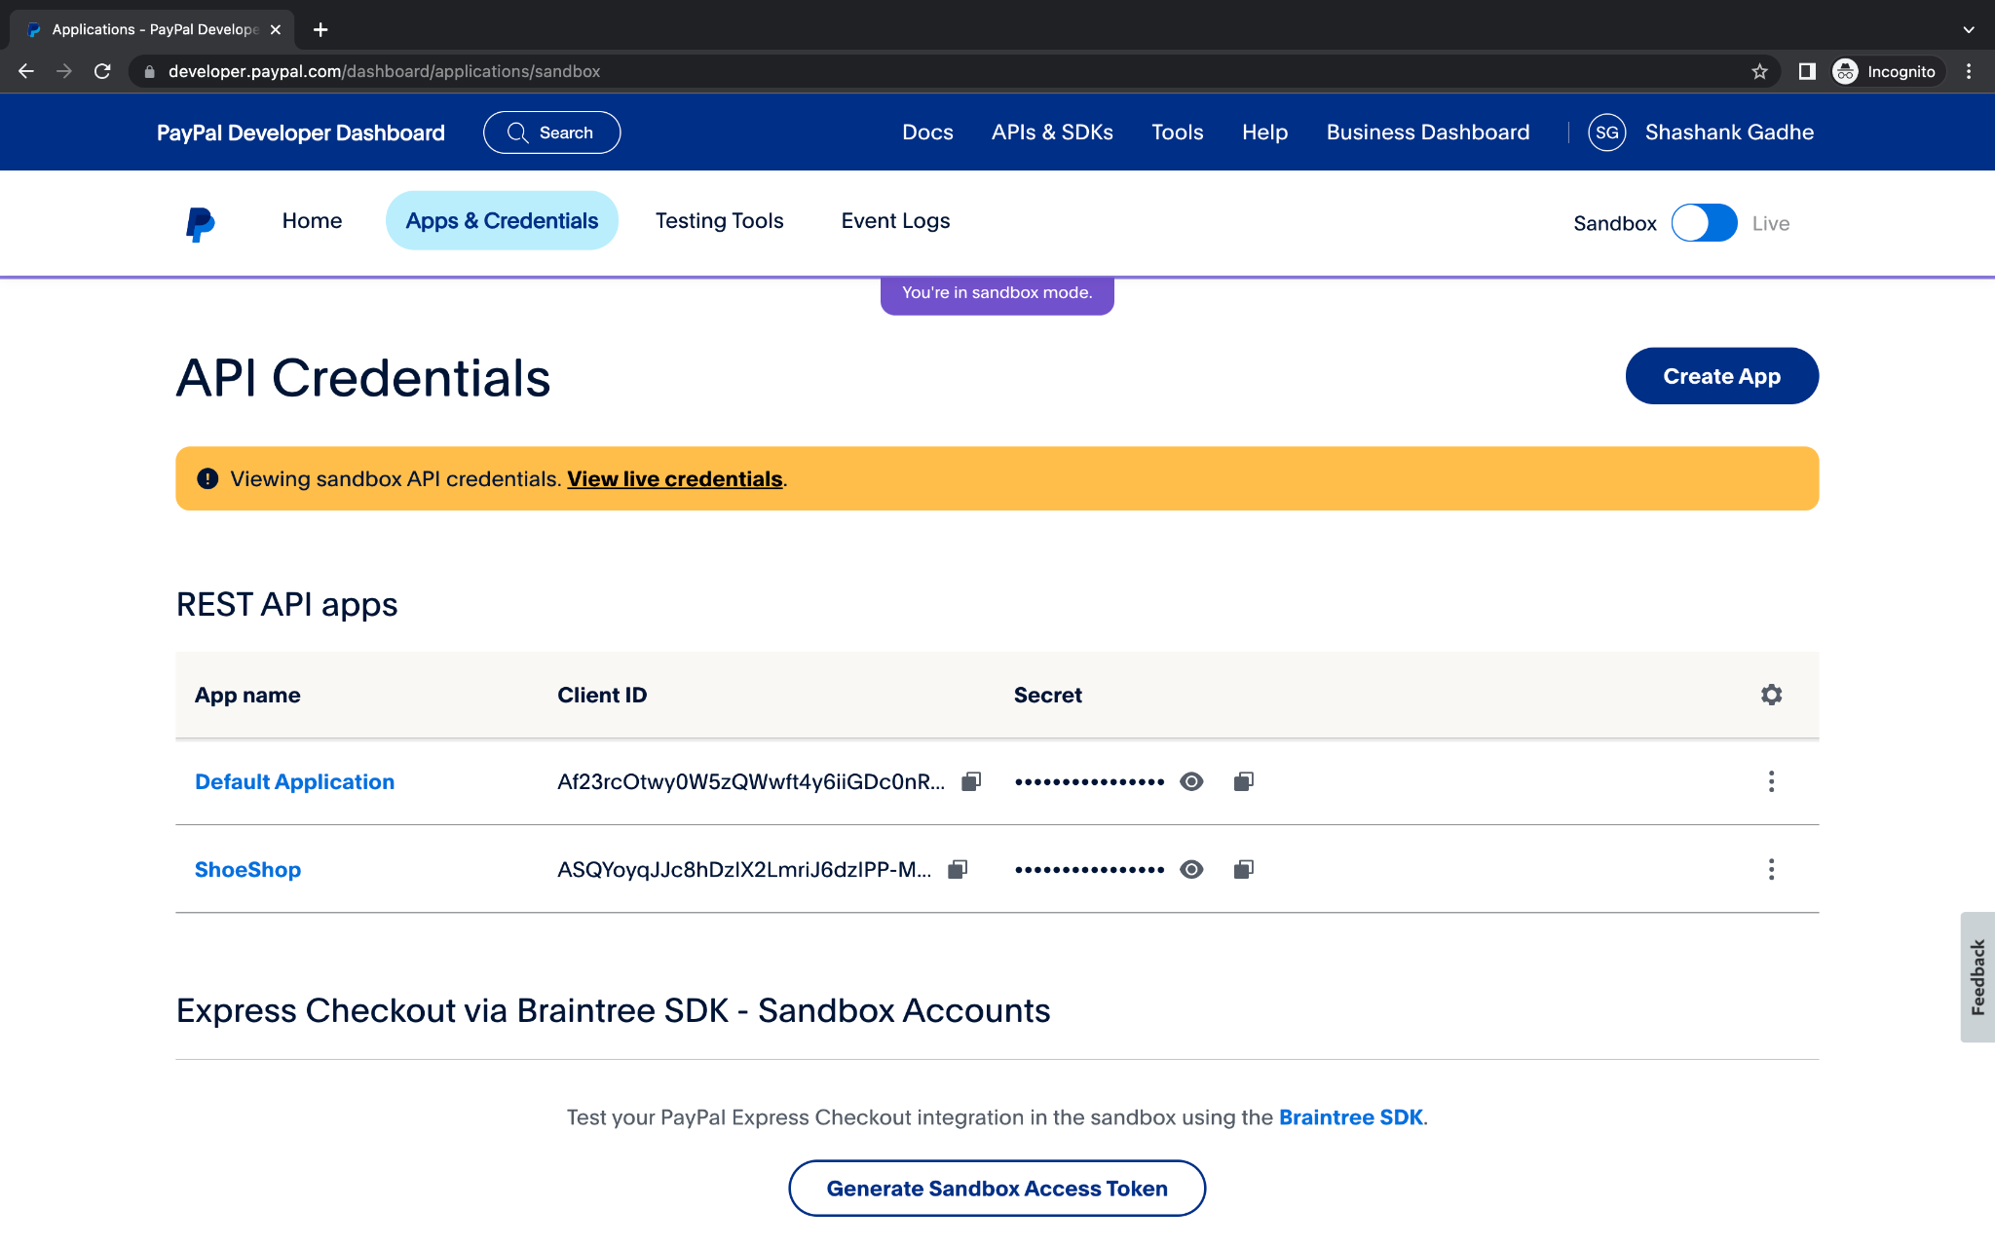

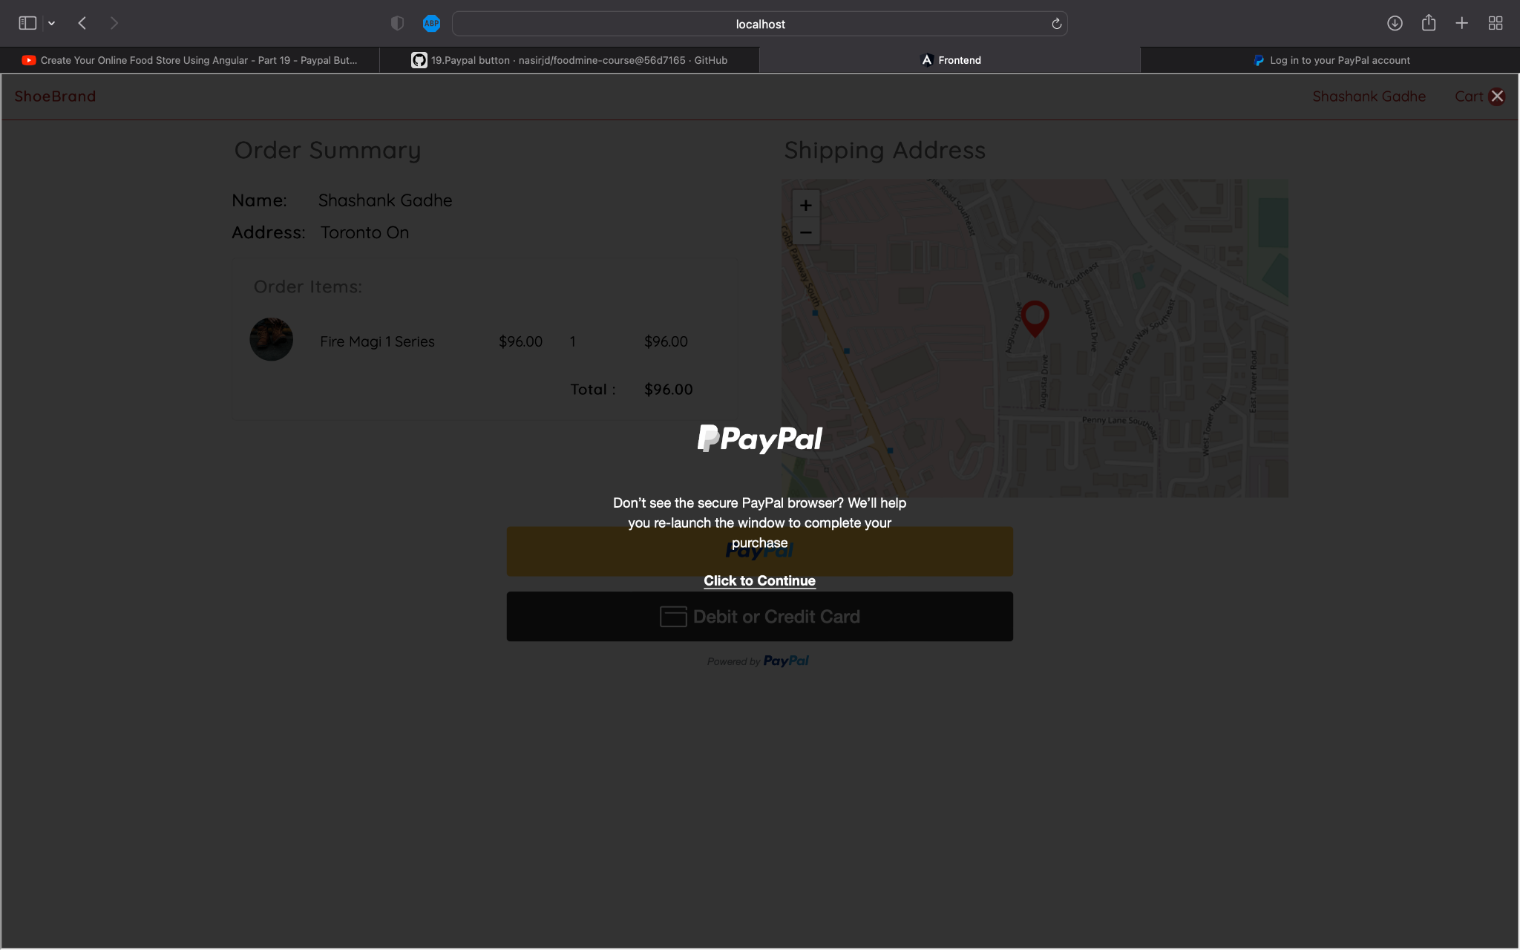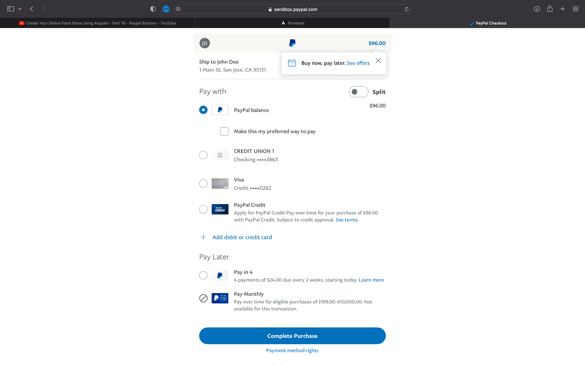

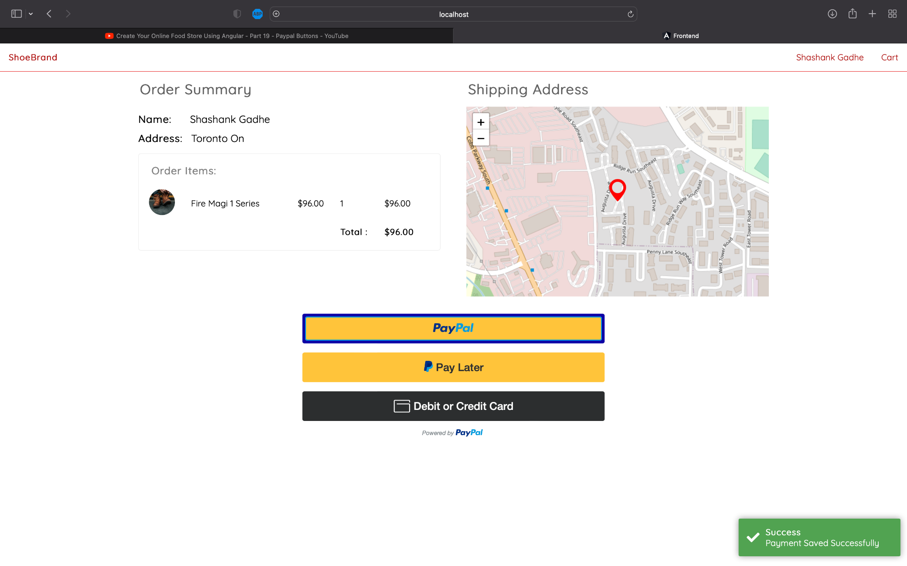

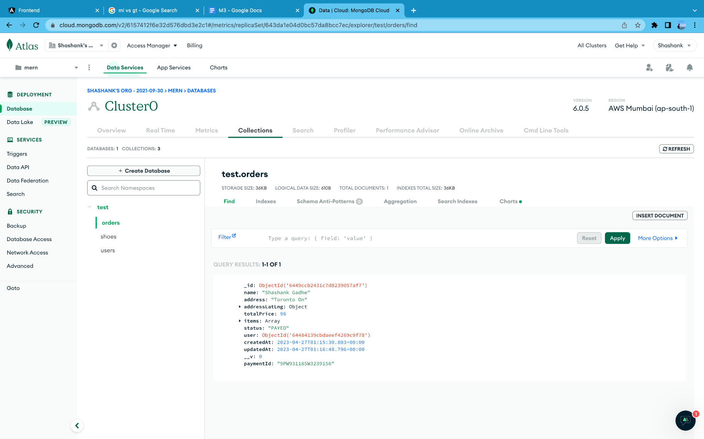

**Instructions for running web application:**

* Change directory (cd frontend) in ShoeShop SRC and run (npm start) and (ng serve)

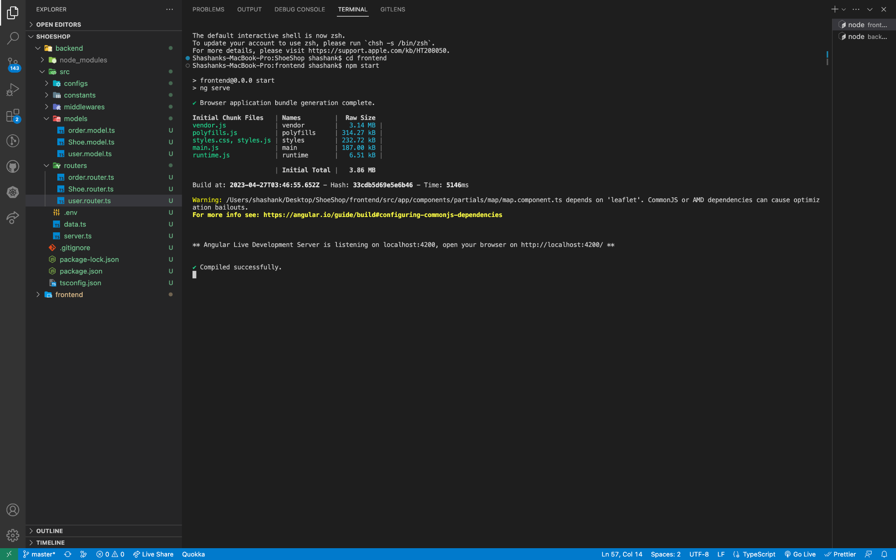

* Change directory (cd backend) in ShoeShop SRC and run (npm start)

